PROCESS HAZARD ANALYSIS
Natural gas distribution network
Integrated DRI-EAF steel works
Worked example for the Process Safety Analysis Toolkit: HAZOP · FMECA · Fault tree · Event tree · Bow tie

Item | Value
Document | HZ-EX-GN-001 rev A (HAZOP) · FM-EX-GN-001 (FMECA) · FT-GN-01/02/03 · ETA-GN-01/02 · BT-GN-01/02
Study dates | HAZOP 12–14 Oct 2026; FMECA 15–16 Oct 2026 (example dates)
Facilitator / scribe | A. Facilitator / B. Scribe (Istec)
Status | Worked training example – complete

IMPORTANT – This is a training example. The plant arrangement, tag numbers, pressures, set points and failure data are representative of an integrated DRI-EAF steel works gas network. They are not taken from the design documents of any real plant and must not be used for decisions about a real plant.

1 Purpose and how to use this example
This report presents a complete process hazard analysis (PHA) of a steel-works natural gas distribution network, carried out with every tool in the Process Safety Analysis Toolkit. It shows how the qualitative HAZOP and FMECA feed the quantitative fault-tree, event-tree and bow-tie analyses, and how the results come back into the HAZOP risk ranking and recommendations. Every study file opens in its toolkit app, so learners can trace each number back to where it is calculated and change the inputs to see the effect.
File (Examples / Steel Works Gas Network PHA) | Open with | Content
Steel works gas network - HAZOP HZ-EX-GN-001.hazop.json | HAZOP Study Manager | 8 nodes, 46 deviations, 115 causes, 63 safeguards (31 IPL credits), 21 recommendations
Steel works gas network - HAZOP_Study_Workbook.xlsx  Steel works gas network - HAZOP_Study_Workbook_Macro.xlsm | Excel | The same HAZOP in the HAZOP Study Workbook (non-macro and macro versions)
Steel works gas network - FMECA_Workbook.xlsx  Steel works gas network - FMECA_Workbook_Macro.xlsm | Excel | FMECA of systems S01–S08 (= nodes N01–N08): 48 equipment items, 33 failure modes
Steel works gas network - FT-GN-01 PRS-1 overpressure.fta.json | Fault Tree & PFD Calculator | MP header overpressure – PRS-1 monitor + slam-shut protection
Steel works gas network - FT-GN-02 Gas detection and ESD.fta.json | Fault Tree & PFD Calculator | Gas detection & ESD isolation of the HP / MP system
Steel works gas network - FT-GN-03 Reheat furnace BMS.fta.json | Fault Tree & PFD Calculator | Reheat furnace BMS flame-failure shut-off
Steel works gas network - ETA-GN-01 Major gas release.eta.json | Event Tree Analysis | Outcomes of a major gas release (jet fire, flash fire, VCE)
Steel works gas network - ETA-GN-02 Reheat furnace flame failure.eta.json | Event Tree Analysis | Outcomes of a reheat furnace flame failure
Steel works gas network - BT-GN-01 Loss of containment.bowtie.json | Bow Tie Analysis | Loss of containment of the HP / MP gas system
Steel works gas network - BT-GN-02 Reheat furnace explosion.bowtie.json | Bow Tie Analysis | Explosive mixture in the reheat furnace
Steel works gas network - What-If WI-EX-GN-001.whatif.json  Steel works gas network - WhatIf_Checklist_Workbook.xlsx | What-If Checklist Analysis / Excel | What-If / Checklist of the non-routine work: 4 tasks, 22 questions (section 2.3)
Cross-link test results.txt | Text editor | Automated consistency checks across all files (section 10)

Workflow used
- What-If / Checklist (section 2.3) screens the non-routine work – purging, isolation, network restart, furnace light-off – and sends the questions that need a deviation analysis to HAZOP nodes.
- HAZOP (all nodes) identifies deviations, causes, consequences, safeguards and IPL candidates, ranks the risk and refers high-consequence scenarios for quantification.
- FMECA of the same systems (S01–S08 = N01–N08) examines how each equipment item fails – the failure modes of protective equipment become basic events in the fault trees.
- Fault trees quantify the protection systems claimed as IPLs: PRS overpressure protection (FT-GN-01), gas detection & ESD (FT-GN-02) and the furnace BMS (FT-GN-03).
- Bow ties put all threats, barriers and consequences of each major top event on one page; the fault-tree gates are linked live as barrier PFDs.
- Event trees develop the outcomes of the top events; their headings use the same fault-tree gates and the same probabilities as the bow-tie barriers.
- Calculated frequencies set the HAZOP 'likelihood after safeguards' of the quantified deviations; gaps against the tolerability criteria become recommendations.

2 Scope and system description
Scope: Natural gas from the supplier's custody-transfer battery limit through the gas receiving & metering station (GRMS), gas heaters and pressure reduction station PRS-1, the 7 barg MP ring main, the district stations and fuel trains of the DRI plant (DS-2), melt shop (DS-3) and rolling-mill reheat furnace (DS-4 / fuel train), the purge / vent / blowdown facilities, and the gas detection & ESD system protecting the network.
Exclusions: Supplier pipeline upstream of ESDV-1001; burner internals and combustion inside the DRI reformer (covered by the DRI plant HAZOP); oxygen plant and O2 distribution (except the NG/O2 interface at oxy-fuel burners); plant N2 generation.
Design intent: Receive natural gas at 35–42 barg (pipeline MAOP 50 barg), filter, meter and heat it, reduce it to 7 barg (MP header design 10 barg) and distribute it to the plant users at the pressure and quality they need, without loss of containment. All values are illustrative – confirm against the gas network design basis, P&IDs and relief / SIL studies.
Operating modes: Normal operation, start-up / re-pressurisation after supply interruption, regulator-run change-over, pigging, purging and gas-in / gas-out for maintenance, emergency shutdown
Natural gas is received from the supplier's pipeline at 35–42 barg, filtered and metered in the GRMS, heated in water-bath heaters to offset Joule–Thomson cooling (about 0.5 °C per bar of pressure drop) and reduced to 7 barg in PRS-1. Each PRS run has an active regulator, a monitor regulator and a slam-shut valve; the outlet token relief valve is not sized for a full regulator failure, so the MP network (design 10 barg) relies on the monitor and slam-shut – the classic design for gas pressure regulating stations. The 7 barg ring main feeds district stations for the DRI plant (reformer fuel and process-gas make-up), the melt shop (EAF oxy-fuel burners, ladle preheaters) and the rolling-mill reheat furnace, whose fuel train is protected by a burner management system (BMS).
Node | Name | Drawing | Design / operating
N01 | Gas receiving & metering station (GRMS) | P&ID-GN-1001 | Design 50 barg / -10 to 60 °C (= pipeline MAOP); 2 x 100 % filter-separators; 2 x 100 % meter runs  35–42 barg; 20–35 °C; up to 120 000 Sm3/h
N02 | Gas heaters H-1101A/B and pressure reduction station PRS-1 | P&ID-GN-1101 | Inlet 50 barg; outlet piping 10 barg design; set points: active 7.0, monitor 7.5, SSV OPSO 8.5, PSV-1105 9.0 barg; outlet temperature ≥ 5 °C  Outlet 6.8–7.2 barg; heater outlet 30–40 °C upstream of the regulators; run A duty / run B standby (set 0.3 bar lower)
N03 | MP ring main (7 barg) and pipe racks | P&ID-GN-1201/1202 | Design 10 barg; API 5L carbon steel; buried sections coated + impressed-current CP  6.8–7.2 barg; ambient temperature
N04 | DRI plant gas supply – district station DS-2 | P&ID-GN-2001 | Design 10 barg (full MP pressure); outlet 4.5 barg  4.0–4.5 barg; flow on reformer firing demand
N05 | Melt shop gas supply – DS-3, EAF oxy-fuel burners and ladle preheaters | P&ID-GN-3001 | Design 10 barg; outlet 2.0 barg; O2 supply to burners 10 barg  1.8–2.0 barg; intermittent firing
N06 | Rolling-mill reheat furnace fuel gas train and burner management | P&ID-GN-4001 | Design 10 barg upstream / 2 barg downstream of PCV-4001; SSOV closing time < 1 s  0.3–1.5 barg at the burners; furnace 900–1250 °C; light-off from cold after outages
N07 | Purge, vent, blowdown and maintenance isolation | P&ID-GN-1301 | Vent stack 3 m above the highest platform within 15 m; N2 purge supply 8 barg  Used during maintenance, pigging and gas-in / gas-out
N08 | Gas detection, F&G and ESD system | C&E-GN-1000 | SIS per SRS-GN-001; ESD valves fail-closed; UPS 30 min  Normally on line; detectors 20 % / 40 % LEL alarm / trip

2.1 Risk criteria
HAZOP risk = severity (1–5) x likelihood (1–5) on the toolkit's 5 x 5 matrix (Low < 5, Medium 5–9, High 10–19, Very High ≥ 20). Likelihood bands: 1 < 1E-4 /yr, 2 1E-4–1E-3, 3 1E-3–1E-2, 4 1E-2–0.1, 5 > 0.1 /yr. Tolerable frequencies used in the event trees and bow ties: catastrophic (multiple fatalities) 1E-4 /yr, major 1E-2 /yr, moderate 1 /yr. For quantified deviations the HAZOP 'likelihood after safeguards' is set from the calculated frequency.

2.2 Team and sessions
Name | Company | Role | Attended
A. Facilitator | Istec | Facilitator | Days 1–3
B. Scribe | Istec | Scribe | Days 1–3
C. Gas Network | Utilities | Process engineer | Days 1–3
D. Operator | Utilities | Operations representative | Days 1–3
E. Instrument | Maintenance | Instrument / control engineer | Days 1–3
F. Mechanical | Maintenance | Mechanical engineer | Days 1–2
G. Safety | HSE | HSE / process safety | Days 1–3
H. Furnace | Rolling mill | Operations representative | Day 3
I. DRI | DRI plant | Process engineer | Day 2

Date | Nodes | Notes
2026-10-12 | N01, N02, N03 | GRMS, PRS-1 and MP ring main. N02-02 referred for quantification (FT-GN-01); releases referred to BT-GN-01 / ETA-GN-01.
2026-10-13 | N04, N05, N07 | District stations DS-2 / DS-3 and purge / vent. NG back-flow into the N2 header (N07-03) linked to the hot DRI conveyor example.
2026-10-14 | N06, N08 | Reheat furnace BMS (FT-GN-03, ETA-GN-02, BT-GN-02) and gas detection / ESD (FT-GN-02). Study closed; FMECA scheduled 15–16 Oct.

2.3 What-If / Checklist analysis
Method: combined What-If / Checklist analysis (CCPS, Guidelines for Hazard Evaluation Procedures, 3rd ed., section 5.2), study WI-EX-GN-001, 2026-10-05. There is no HAZID in this example, so it is the first screening of these tasks; it prepares the HAZOP HZ-EX-GN-001: the team listed What-If questions for each area or task, used the checklist to cover any gaps, and then decided for each question whether it is closed at What-If level, sent to a HAZOP node, or sent to a quantified study.
Four non-routine tasks on the natural gas network: purging a main into and out of service, maintenance isolation of a ring-main section, restarting the network after a site-wide gas shutdown, and the reheat furnace light-off. Questions that need a systematic deviation analysis are sent to HAZOP nodes N03–N08.
No. | Area / function / task | Type | Checklist packs | Checklist answered | Gaps (No / ?) | What-Ifs | Feeds HAZOP
A01 | Purging a gas main into and out of service | Task / procedure | GEN, FG | 8 | 2 | 5 | N07
A02 | Maintenance isolation of a ring-main section | Task / procedure | GEN, FG | 6 | 2 | 5 | N03, N07
A03 | Restart of the gas network after a site-wide gas shutdown | Task / procedure | GEN, FG | 5 | 2 | 6 | N04, N05, N08
A04 | Reheat furnace light-off | Task / procedure | GEN, FG | 5 | 1 | 6 | N06

Checklist gaps (answered No or ?) and the What-If question each raised:
Area | Item | Checklist question | Answer | Note | What-If
A01 | GEN-SSD-02 | Is equipment purged of air or process material before start-up or maintenance? | ? | End-point O2 test not recorded | A01-01
A01 | FG-SSD-02 | Is the restart of the gas network after a site-wide trip controlled step by step? | ? | No written restart sequence
A02 | FG-MNT-01 | Are spades and slip plates used to isolate gas mains for maintenance? | No | Isolation by closed valve is common | A02-01
A02 | FG-MNT-03 | Are bleeder valves on mains operated and checked during isolation? | ? | Bleeders not on the certificate | A02-04
A03 | FG-SSD-02 | Is the restart of the gas network after a site-wide trip controlled step by step? | No | No site-wide restart procedure | A03-01
A03 | GEN-SSD-04 | Are trips that are inhibited for start-up re-armed automatically? | ? | Detector inhibits not checked after shutdown | A03-05
A04 | GEN-INS-03 | Is trip bypassing controlled by permit and time limit? | ? | Bypasses not logged | A04-03

What-If worksheet – A01 Purging a gas main into and out of service (task / procedure)
Ref | What if…? | Consequence | Safeguards | Risk before | Recommendation | Risk after | Next step
A01-01 | What if the main is purged with too little nitrogen and air remains when gas is admitted? | Flammable mixture in the main – ignition at a vent or user | • Purge plan OP-GN-020 (O2 < 2 %) | 5 x 3 = 15 | WR-01 Record the O2 end-point (< 2 %) at the far-end vent with a calibrated analyser on the purge sheet before gas-in. | 5 x 1 = 5 | Send to HAZOP → N07-01
A01-02 | What if purge nitrogen is vented inside the PRS shelter? | Asphyxiation of the operator | • Personal O2 monitors  • Confined-space entry permit | 5 x 2 = 10 |  | 5 x 1 = 5 | Send to HAZOP → N07-02
A01-03 | What if natural gas flows back into the plant nitrogen system through the purge connection? | Gas released wherever nitrogen is used | • Removable N2 spool with check valve | 4 x 3 = 12 |  | 4 x 2 = 8 | Send to HAZOP → N07-03
A01-04 | What if the vent stack discharges where people are working? | Fire or asphyxiation at the platform | • VS-1301 – Vent stack 3 m above the nearest platform | 4 x 2 = 8 |  | 4 x 1 = 4 | Send to HAZOP → N07-04
A01-05 | What if gas-in starts before every burner valve on the section is closed? | Explosion in a user furnace or preheater | • PSLL-2006 – Low-low pressure trips in the users' BMS [IPL] | 5 x 3 = 15 | WR-02 Add a users' valve check-list to the gas-in procedure: every burner valve on the section proven closed before gas-in. | 5 x 1 = 5 | Send to HAZOP → N03-03

What-If worksheet – A02 Maintenance isolation of a ring-main section (task / procedure)
Ref | What if…? | Consequence | Safeguards | Risk before | Recommendation | Risk after | Next step
A02-01 | What if a section is isolated by one closed valve only? | Gas leaks into the section being worked on – fire | • Permit-to-work with isolation verification | 5 x 3 = 15 | WR-03 Make spades or spectacle blinds mandatory for every section isolation; single-valve isolation only for gas-tight tests. | 5 x 1 = 5 | Send to HAZOP → N07-06
A02-02 | What if hot work starts on a main that has not been proven gas-free? | Explosion during cutting or welding | • Hot-tapping and hot-work procedures  • Gas test before hot work | 5 x 2 = 10 |  | 5 x 1 = 5 | Send to HAZOP → N07-05
A02-03 | What if the wrong sectionalising valve is closed? | Gas release when the flange is broken | • XV-1201 – Remote sectionalising valves  • Valve line-up checklist | 4 x 3 = 12 |  | 4 x 2 = 8 | Send to HAZOP → N03-06
A02-04 | What if a bleeder is left closed during the isolation? | Gas release at the work point | • Isolation certificate | 4 x 3 = 12 | WR-04 Open and check the bleeders at each isolation point and record them on the isolation certificate. | 4 x 1 = 4 | Closed at What-If
A02-05 | What if an excavation near the ring main damages the pipe? | Gas leak from the ring main | • Ground-disturbance permit with buried-services check | 5 x 2 = 10 |  | 5 x 1 = 5 | Send to HAZOP → N03-01

What-If worksheet – A03 Restart of the gas network after a site-wide gas shutdown (task / procedure)
Ref | What if…? | Consequence | Safeguards | Risk before | Recommendation | Risk after | Next step
A03-01 | What if gas is re-admitted while users' burners are still open? | Unburnt gas in a furnace – explosion at re-ignition | • BMS-4000 – Burner management [IPL]  • PSLL-4005 – Low-low gas pressure trip [IPL] | 5 x 3 = 15 | WR-05 Write a site-wide gas restart procedure: PRS-1 first, then district stations one at a time, users released only by their own operators. | 5 x 2 = 10 | Send to quantified study (FT / ETA / bow tie) → FT-GN-03
A03-02 | What if the PRS regulator fails open when the network is re-pressured? | Ring-main overpressure – flange leaks | • SSV-1102A – Slam-shut valve [IPL]  • PSV-1105 – Token relief valve | 5 x 2 = 10 |  | 5 x 1 = 5 | Send to quantified study (FT / ETA / bow tie) → FT-GN-01
A03-03 | What if a district-station regulator fails open at restart? | User piping over-pressured | • District-station piping designed for full MP pressure [IPL] | 4 x 3 = 12 |  | 4 x 2 = 8 | Send to HAZOP → N04-05
A03-04 | What if oxygen is in the gas line at the oxy-fuel burners after the restart? | Explosion in the burner line | • XV-3011 – O2 and NG shut-off on low NG pressure [IPL] | 5 x 2 = 10 |  | 5 x 1 = 5 | Send to HAZOP → N05-01
A03-05 | What if gas detectors are still inhibited after the shutdown? | Leak at restart not detected; no ESD | • Quarterly detector bump tests | 5 x 3 = 15 | WR-06 Check and clear all gas-detector inhibits before the network is re-pressured; list them on the restart checklist. | 5 x 2 = 10 | Send to quantified study (FT / ETA / bow tie) → FT-GN-02
A03-06 | What if power returns and valves reopen by themselves? | Gas sent to users before they are ready | • UPS-1000 – UPS for SIS and F&G  • De-energise-to-trip valves | 4 x 3 = 12 |  | 4 x 2 = 8 | Send to HAZOP → N08-02

What-If worksheet – A04 Reheat furnace light-off (task / procedure)
Ref | What if…? | Consequence | Safeguards | Risk before | Recommendation | Risk after | Next step
A04-01 | What if a burner is lit before the pre-purge is complete? | Furnace explosion | • BMS-4000 – Pre-purge interlock [IPL]  • Light-off procedure OP-RM-040 | 5 x 3 = 15 |  | 5 x 1 = 5 | Send to HAZOP → N06-04
A04-02 | What if the safety shut-off valves pass gas into the furnace during the purge? | Explosive mixture at light-off | • VPS-4004 – Valve proving of XV-4002A/B [IPL] | 5 x 2 = 10 |  | 5 x 1 = 5 | Send to HAZOP → N06-05
A04-03 | What if the BMS is bypassed to get the furnace going? | Explosion on flame failure | • Management of change for BMS logic | 5 x 3 = 15 | WR-07 Enforce the bypass register for BMS-4000: no bypass during light-off; supervisor sign-off and time limit. | 5 x 1 = 5 | Send to HAZOP → N06-06
A04-04 | What if a ladle preheater is lit by hand with its burner management bypassed? | Explosion in the preheater | • LPH-3020 – Preheater burner management [IPL] | 5 x 3 = 15 |  | 5 x 2 = 10 | Send to HAZOP → N05-04
A04-05 | What if the flame goes out with fuel gas still flowing? | Unburnt gas in the furnace – explosion | • BMS-4000 – Flame-failure shut-off [IPL]  • PSLL-4005 – Low-low gas pressure trip [IPL] | 5 x 2 = 10 |  | 5 x 1 = 5 | Send to quantified study (FT / ETA / bow tie) → ETA-GN-02
A04-06 | What if someone enters the furnace with the gas not positively isolated? | Asphyxiation or fire inside the furnace | • Spade isolation of the fuel gas  • Confined-space entry permit | 5 x 2 = 10 |  | 5 x 1 = 5 | Send to HAZOP → N06-07

Outcome: 1 questions closed at What-If level, 17 sent to the HAZOP, 4 sent to quantified studies, 0 need further information. 7 What-If recommendations (WR-xx) are tracked with the HAZOP recommendations.

3 HAZOP results summary
46 deviations were recorded across 8 nodes; 38 were High / Very High before safeguards and 13 remain High after the existing safeguards – all of these are severity-5 scenarios at likelihood 2 (1E-4 to 1E-3 /yr) or severity-4 scenarios at likelihood 3, and each has at least one recommendation. Figure 1 shows the HAZOP Study Manager dashboard for this study.
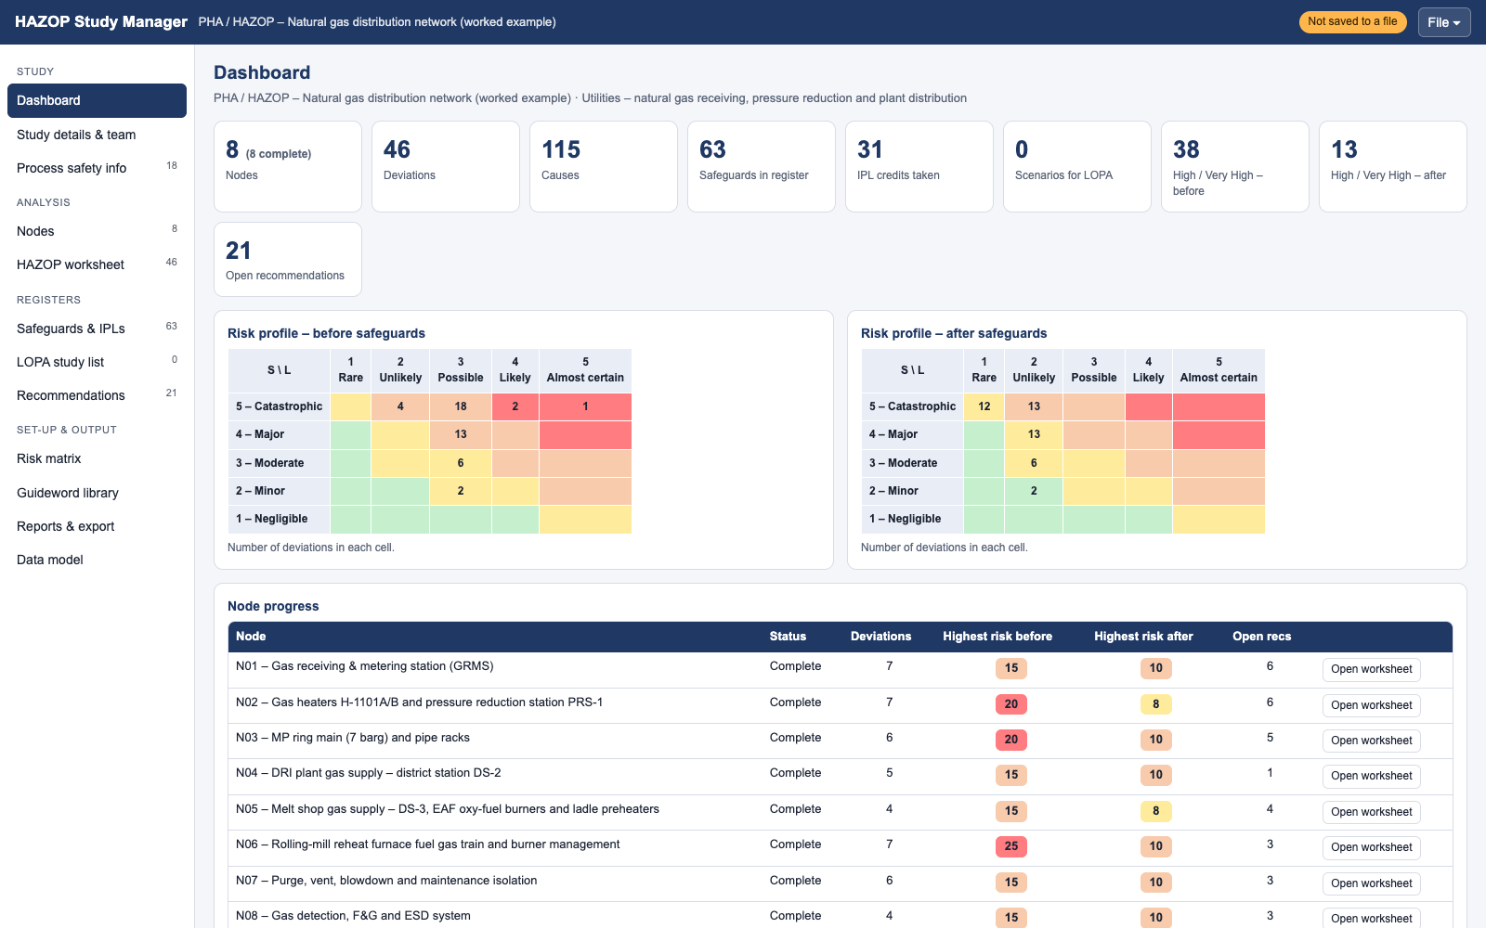
Figure 1 – HAZOP Study Manager dashboard with the example loaded (rendered by the app in Chrome)
Node | Name | Deviations | Highest risk before | Highest risk after | Recommendations
N01 | Gas receiving & metering station (GRMS) | 7 | 15 | 10 | 6
N02 | Gas heaters H-1101A/B and pressure reduction station PRS-1 | 7 | 20 | 8 | 6
N03 | MP ring main (7 barg) and pipe racks | 6 | 20 | 10 | 5
N04 | DRI plant gas supply – district station DS-2 | 5 | 15 | 10 | 1
N05 | Melt shop gas supply – DS-3, EAF oxy-fuel burners and ladle preheaters | 4 | 15 | 8 | 4
N06 | Rolling-mill reheat furnace fuel gas train and burner management | 7 | 25 | 10 | 3
N07 | Purge, vent, blowdown and maintenance isolation | 6 | 15 | 10 | 3
N08 | Gas detection, F&G and ESD system | 4 | 15 | 10 | 3

Key scenarios referred for quantification
HAZOP | Scenario | Quantified in | Result | Likelihood after
N02-02 / N03-02 | MP network overpressure from PRS-1 regulator failure | FT-GN-01; BT-GN-01 T1 | Overpressure 3.6E-5 /yr; protection PFDavg 2.0E-4 | 1
N01-05 / N02-05 / N08-01 | Major gas release in the GRMS / PRS | BT-GN-01, ETA-GN-01, FT-GN-02 | Release 5.8E-3 /yr; VCE 4.3E-6 /yr; ESD PFDavg 2.6E-2 | 1
N06-01 | Reheat furnace flame failure with fuel flowing | FT-GN-03, ETA-GN-02, BT-GN-02 T1 | BMS PFDavg 1.1E-2; explosion 9.2E-4 /yr (target 1E-4) | 2

4 HAZOP worksheets
Full worksheets (one row per deviation). [IPL] marks a safeguard claimed as an independent protection layer for that deviation. Risk = S x L before → after safeguards.

N01 – Gas receiving & metering station (GRMS)
Design intent: Receive natural gas from the supplier's pipeline, remove liquids and solids and meter it for custody transfer. Battery limits: From the supplier battery-limit insulating joint IJ-1001 through inlet ESD valve ESDV-1001, pig receiver PR-1001, filter-separators F-1002A/B and ultrasonic meter runs FT-1003A/B to the inlet of the gas heaters.
Ref | Deviation | Causes | Consequences / notes | Risk before | Safeguards | Risk after | Recs
N01-01 | Flow / NO  No gas supply from the pipeline | • Supplier pipeline trip / supplier ESD  • Spurious closure of ESDV-1001 (solenoid, power or air failure)  • Both filter-separators F-1002A/B blocked (black powder) | Loss of gas to all users: reformer, reheat furnace, preheater and oxy-fuel burner flame-outs and trips; on uncontrolled restoration of supply, gas may enter burners that are not proven shut – accumulation and explosion on relight (see N06-01); production loss  Restoration after an interruption is the hazardous phase – see N06 and R-006. | 3 x 3 = 9 | • PSLL-2006 / PSLL-4005 – Low-low gas pressure trips in the user burner management systems (reformer, reheat furnace, preheaters) [IPL]  • F-1002A/B – Duty / standby filter-separators with LSH-1002 high-liquid alarm and PDIT-1002 differential-pressure alarm  • Gas supply agreement quality specification; supplier notification of off-spec gas and supply interruptions | 3 x 2 = 6 | R-006
N01-02 | Pressure / MORE  Inlet pressure above GRMS design | • Failed-open pressure control valves (PCVs)  • Supplier pressure excursion above normal operating range  • Thermal expansion of trapped (blocked-in) liquid | Overpressure of filter-separators / meter runs only if their design pressure were below the pipeline MAOP; blocked-in sections heated by the sun – flange leak, release of high-pressure gas (bow tie BT-GN-01)  GRMS designed for the pipeline MAOP (50 barg) – overpressure from the supplier not credible. | 5 x 2 = 10 | • GRMS piping, filter-separators and meter runs designed for the pipeline MAOP (no overpressure from the supplier) [IPL]  • PSV-1006A/B – Filter-separator fire-case / thermal relief valves [IPL]  • PT-1005 – GRMS inlet pressure high alarm PAH-1005 with operator response | 5 x 1 = 5 | –
N01-03 | Flow / AS WELL AS  Liquids / solids carried in the gas | • Gas or air entrainment in liquid; liquid carry-over in gas  • Pigging debris and black powder from the supplier pipeline  • Condensate from the pipeline after cold weather / pigging | Filter-separator overload; liquid / dust carry-over to meters and regulator pilots – active regulator may stick open (demand on overpressure protection, N02-02); erosion; liquid slugs cause flame instability at burners  Carry-over is one of the initiating causes in fault tree FT-GN-01 (active regulator fails open). | 4 x 3 = 12 | • F-1002A/B – Duty / standby filter-separators with LSH-1002 high-liquid alarm and PDIT-1002 differential-pressure alarm  • Operator rounds with portable gas detector; annual acoustic leak survey | 4 x 2 = 8 | R-016
N01-04 | Composition / OTHER THAN  Gas composition outside specification | • Wrong raw material delivered or unloaded  • H2S / higher hydrocarbons above the supply specification  • Wobbe index change (supplier gas source change) | H2S poisons the DRI reformer catalyst and is toxic on release; Wobbe index change alters burner heat release – over-firing or flame instability in the reheat furnace and preheaters  Composition is also reviewed for the DRI plant in N04-04. | 3 x 3 = 9 | • AT-1004 – Gas chromatograph – composition, Wobbe index and H2S monitoring with alarm  • Gas supply agreement quality specification; supplier notification of off-spec gas and supply interruptions | 3 x 2 = 6 | –
N01-05 | Process gas / LEAK OF  Leak of natural gas at the GRMS | • Flange, valve or seal leak; water-seal blown  • Small-bore fitting fatigue (meter-run vibration)  • Pig receiver closure opened or leaking under pressure | High-pressure natural gas release fed from the pipeline inventory: jet fire if ignited immediately; flash fire or vapour cloud explosion if ignited later – potential multiple fatalities and loss of gas to the whole works (event tree ETA-GN-01)  Quantified: bow tie BT-GN-01 (top event = loss of containment of the HP / MP system), event tree ETA-GN-01 (initiating event = BT-GN-01 top), fault tree FT-GN-02 (ESD). Likelihood after safeguards from the calculated frequency 4.3E-6 /yr. | 5 x 3 = 15 | • UCP-1000 – Gas detection GD-1110A/B/C (2oo3) and ESD isolation of the HP / MP system – ESDV-1001 and ESDV-1107 close (SIS UCP-1000) [IPL]  • Ignition source control – hazardous area classification with Ex equipment, hot-work permit, vehicle control  • PR-1001 – Pig receiver quick-opening closure with pressure-warning / locking device (key interlock with vent valve) [IPL]  • Separation distances and fire-proofing of supports in the GRMS / PRS  • Emergency response team / fire brigade; emergency response plan for gas releases and fires | 5 x 1 = 5 | R-001, R-017, R-021
N01-06 | Corrosion / erosion / MORE  External corrosion of the buried inlet line / insulating joint | • Cathodic protection arrangements inadequate  • Insulating joint IJ-1001 shorted (debris, bonding cable)  • Coating damage at road crossings | Wall loss leading to a leak or rupture of the buried section – gas migrates through soil into trenches / buildings (bow tie BT-GN-01 threat 2)  FMECA S03 CP-1200; bow tie BT-GN-01 threat T2. | 5 x 3 = 15 | • CP-1200 – Coating and impressed-current cathodic protection of buried sections; annual CP / DCVG survey  • Piping inspection programme – thickness monitoring at supports, rack crossings and low points | 5 x 2 = 10 | R-008
N01-07 | Maintenance / INADEQUATE  Unsafe pigging / maintenance on the GRMS | • Isolation, drainage, purging  • Pig receiver opened before full depressurisation  • Work permit system | Pig receiver door blown open or gas release onto the operator; pyrophoric iron sulphide in pig debris ignites on exposure to air  Bow tie BT-GN-01 threat T5 (maintenance error). | 5 x 3 = 15 | • PR-1001 – Pig receiver quick-opening closure with pressure-warning / locking device (key interlock with vent valve) [IPL]  • Pigging procedure OP-GN-010: depressurise, N2 purge and gas test before opening the pig receiver  • Permit-to-work with isolation verification (DBB / spades), gas-free test and fire watch | 5 x 1 = 5 | R-017

N02 – Gas heaters H-1101A/B and pressure reduction station PRS-1
Design intent: Pre-heat the gas to offset Joule–Thomson cooling (~0.5 °C per bar) and reduce it from 35–42 barg to 7 barg without exceeding the MP design pressure. Battery limits: From the heater inlet through water-bath heaters H-1101A/B and regulator runs A/B (slam-shut SSV-1102, monitor PCV-1103, active PCV-1104) to outlet ESD valve ESDV-1107, incl. token relief PSV-1105.
Ref | Deviation | Causes | Consequences / notes | Risk before | Safeguards | Risk after | Recs
N02-01 | Temperature / LESS  Gas temperature downstream of the regulators too low | • Heater H-1101A trip (flame failure, low bath level)  • Heater undersized at peak flow / TIC-1101 fault  • Reducing pressure (auto-refrigeration of LPG, CO2, ammonia) | Joule–Thomson cooling (~0.5 °C per bar, ~17 °C for 42 → 7 barg) – outlet below 0 °C: hydrate / ice in regulator pilots (active regulator may fail open – demand on N02-02 protection); piping below its MDMT – brittle fracture  Ice in the pilot is an initiating cause in fault tree FT-GN-01 (BE-001). | 4 x 3 = 12 | • H-1101A/B – Duty / standby water-bath gas heaters with outlet temperature control TIC-1101  • TT-1101 – Low gas outlet temperature alarm TSL-1101 (+5 °C) with operator response  • H-1101A/B – Heater burner management: flame failure, low bath level LSLL and high bath temperature TSHH trips | 4 x 2 = 8 | R-004
N02-02 | Pressure / MORE  PRS outlet pressure above MP design pressure (10 barg) | • Failed-open pressure control valves (PCVs)  • Regulator sensing line blocked or isolated  • Ice / debris in the active regulator pilot | Overpressure of the whole MP network (inlet up to 42 barg vs 10 barg design): flange leaks and possible rupture across the site, overpressure of district stations and burner trains – fires / explosions at several locations  Quantified: fault tree FT-GN-01 – top = MP header overpressure 3.6E-5 /yr; gate G-002 (monitor + slam-shut) PFDavg 2.0E-4; bow tie BT-GN-01 threat T1. PSV-1105 is a token relief and is not credited. Likelihood after safeguards from the calculated frequency 3.6E-5 /yr. | 5 x 4 = 20 | • PCV-1103A/B – Monitor regulator takes over on active-regulator failure (set 7.5 barg) [IPL]  • SSV-1102A/B – Slam-shut valve with over-pressure shut-off (OPSO 8.5 barg) on each regulator run [IPL]  • PSV-1105 – Token relief valve (9.0 barg) to VS-1301 – lock-up creep / small leaks only, not sized for full regulator failure  • PT-1106 – PRS outlet high-pressure alarm PAH-1106 (7.8 barg) with operator response  • Regulator-run bypass valves car-sealed / locked closed (CSC register) | 5 x 1 = 5 | R-002, R-003
N02-03 | Pressure / LESS  Low PRS outlet pressure | • Slam-shut SSV-1102A spurious trip  • Active and monitor regulators fail closed / filter blocked  • Hydrate in regulator pilot | Low header pressure: flame-out at reheat furnace, preheaters and reformer burners; danger on relight if the burner shut-off is not proven (see N06)  Run B takes over automatically if run A closes. | 3 x 3 = 9 | • Standby regulator run B on automatic (set 0.3 bar lower) – takes over if run A closes  • PSLL-2006 / PSLL-4005 – Low-low gas pressure trips in the user burner management systems (reformer, reheat furnace, preheaters) [IPL]  • PT-1210 – MP header low-pressure alarm PAL-1210 (leak / supply-loss indication) | 3 x 2 = 6 | R-006
N02-04 | Flow / MORE  Gas demand above PRS capacity | • Control faults – control valve fails open, bypass left open, wrong set point  • All users at maximum firing during DRI module start-up | Regulators fully open, outlet pressure sags, extra Joule–Thomson cooling, high velocity – noise, erosion and vibration of regulator runs  Operability issue – capacity check in the design basis. | 2 x 3 = 6 | • Standby regulator run B on automatic (set 0.3 bar lower) – takes over if run A closes  • PT-1210 – MP header low-pressure alarm PAL-1210 (leak / supply-loss indication) | 2 x 2 = 4 | –
N02-05 | Process gas / LEAK OF  Gas release inside the PRS shelter | • Flange, valve or seal leak; water-seal blown  • Regulator diaphragm rupture venting through the pilot vent  • Gas detection inoperative or poorly located | Gas accumulates in the partly enclosed shelter – confined explosion; jet fire on the regulator runs (event tree ETA-GN-01)  Bow tie BT-GN-01 threat T6; event tree ETA-GN-01. Likelihood after safeguards from the calculated frequency 4.3E-6 /yr. | 5 x 3 = 15 | • VS-1301 – Regulator pilot / diaphragm vents and PSV discharges piped to vent stack VS-1301 outside the PRS shelter  • PRS shelter natural ventilation (louvres at high and low level)  • UCP-1000 – Gas detection GD-1110A/B/C (2oo3) and ESD isolation of the HP / MP system – ESDV-1001 and ESDV-1107 close (SIS UCP-1000) [IPL]  • Ignition source control – hazardous area classification with Ex equipment, hot-work permit, vehicle control | 5 x 1 = 5 | R-005, R-001
N02-06 | Temperature / MORE  Heater bath over-temperature / dry firing | • Defective control (TIC fault, heater fails on)  • Low bath level (evaporation, leak)  • Gas coil leak into the water bath | Fire-tube overheating and failure – heater fire; a gas-coil leak vents gas through the bath vent next to the firebox – fire / explosion at the heater  FMECA S02 H-1101A. | 4 x 3 = 12 | • H-1101A/B – Heater burner management: flame failure, low bath level LSLL and high bath temperature TSHH trips [IPL]  • Operator rounds with portable gas detector; annual acoustic leak survey | 4 x 2 = 8 | R-004
N02-07 | Relief / INADEQUATE  Relief not sized for regulator failure | • Relief philosophy not defined for all scenarios (fire, blocked outlet, runaway, tube rupture)  • Relief valve discharge location unsafe (to work areas, ignition sources) | PSV-1105 is a token relief – full-flow regulator failure relies on the monitor regulator and slam-shut; vent discharge near the heaters could ignite  Accepted design practice for gas pressure regulating stations: two independent overpressure protections instead of full-flow relief. | 5 x 2 = 10 | • PCV-1103A/B – Monitor regulator takes over on active-regulator failure (set 7.5 barg) [IPL]  • SSV-1102A/B – Slam-shut valve with over-pressure shut-off (OPSO 8.5 barg) on each regulator run [IPL]  • VS-1301 – Vent stack VS-1301 3 m above the nearest platform, away from heater flues; N2 snuffing | 5 x 1 = 5 | R-002, R-005

N03 – MP ring main (7 barg) and pipe racks
Design intent: Distribute 7 barg gas to all plant users with sectional isolation and without loss of containment. Battery limits: From ESDV-1107 around the plant ring main (24") with sectionalising valves XV-1201…1204 to the inlet isolation of each district station (DS-2, DS-3, DS-4); buried road crossings with cathodic protection CP-1200.
Ref | Deviation | Causes | Consequences / notes | Risk before | Safeguards | Risk after | Recs
N03-01 | Process gas / LEAK OF  Leak from the MP ring main | • Flange, valve or seal leak; water-seal blown  • Mechanical impact by mobile cranes / vehicles at rack crossings  • External corrosion of buried crossings or at pipe supports  • Third-party excavation | Release in congested plant areas (melt shop, rolling mill): jet fire or vapour cloud explosion; gas migrating into cable trenches and building HVAC intakes – explosion inside buildings  Bow tie BT-GN-01 threats T2 (corrosion), T3 (impact), T4 (flange / fitting failure). | 5 x 3 = 15 | • CP-1200 – Coating and impressed-current cathodic protection of buried sections; annual CP / DCVG survey  • Crash barriers and height gantries at pipe-rack road crossings; lift plans for cranes near racks  • Ground-disturbance / excavation permit with buried-services drawing  • PT-1210 – MP header low-pressure alarm PAL-1210 (leak / supply-loss indication)  • XV-1201…1204 – Remote-operated sectionalising valves on the MP ring main  • Ignition source control – hazardous area classification with Ex equipment, hot-work permit, vehicle control | 5 x 2 = 10 | R-007, R-009
N03-02 | Pressure / MORE  MP header overpressure | • Failed-open pressure control valves (PCVs)  • Leakage from interconnected high-pressure system | As N02-02 – whole MP network above its 10 barg design pressure  Covered by N02-02 and fault tree FT-GN-01; recorded here so the node is complete. Likelihood after safeguards from the calculated frequency 3.6E-5 /yr. | 5 x 4 = 20 | • PCV-1103A/B – Monitor regulator takes over on active-regulator failure (set 7.5 barg) [IPL]  • SSV-1102A/B – Slam-shut valve with over-pressure shut-off (OPSO 8.5 barg) on each regulator run [IPL] | 5 x 1 = 5 | R-003
N03-03 | Air / oxygen in process gas / AS WELL AS  Air in the header after maintenance | • Inadequate purging at start-up / shutdown  • Air ingress through leaks at negative pressure | Flammable gas / air mixture inside the header on gas-in – internal deflagration, flashback at the first burner lit  See N07-01. | 5 x 2 = 10 | • Written purge plan OP-GN-020: N2 purge to O2 < 2 % before gas-in and gas > 90 % at the vent before relight (portable analyser)  • Valve line-up checklist and spectacle-blind register | 5 x 1 = 5 | R-015
N03-04 | Corrosion / erosion / MORE  Corrosion of the ring main | • Internal / external corrosion protection  • Corrosion at pipe supports on the racks  • Cathodic protection arrangements inadequate | Wall loss – leak (as N03-01)  FMECA S03 L-1200 and CP-1200. | 5 x 3 = 15 | • CP-1200 – Coating and impressed-current cathodic protection of buried sections; annual CP / DCVG survey  • Piping inspection programme – thickness monitoring at supports, rack crossings and low points | 5 x 2 = 10 | R-009
N03-05 | Electrical safety / static / INADEQUATE  Stray currents and induced voltages on the gas pipework | • EAF / LF high-current systems inducing voltages on nearby pipework  • Insulating joints bypassed; lightning | Arcing at flanges during maintenance – ignition of a gas release; accelerated stray-current corrosion of buried sections  Steel-works specific – see FMECA S03. | 4 x 3 = 12 | • Bonding / earthing of pipe racks, lightning protection and insulating joints at building entries  • CP-1200 – Coating and impressed-current cathodic protection of buried sections; annual CP / DCVG survey | 4 x 2 = 8 | R-008
N03-06 | Operator action / OTHER THAN  Wrong sectionalising valve operated | • Isolation in error (wrong valve closed, LOTO on wrong equipment)  • Valve line-up not checked | Loss of gas to a whole plant area – flame-outs (as N02-03); maintenance on a section believed isolated but still live | 4 x 3 = 12 | • Valve line-up checklist and spectacle-blind register  • Permit-to-work with isolation verification (DBB / spades), gas-free test and fire watch  • PSLL-2006 / PSLL-4005 – Low-low gas pressure trips in the user burner management systems (reformer, reheat furnace, preheaters) [IPL] | 4 x 2 = 8 | –

N04 – DRI plant gas supply – district station DS-2
Design intent: Supply natural gas to the DRI reformer burners (fuel) and as make-up to the reducing-gas circuit at controlled pressure and flow. Battery limits: From the DS-2 inlet ESDV-2001 via regulators PCV-2002A/B to the reformer fuel gas control valve FCV-2004 and the process-gas NG make-up point (XV-2008).
Ref | Deviation | Causes | Consequences / notes | Risk before | Safeguards | Risk after | Recs
N04-01 | Flow / MORE  Excess fuel gas to the reformer burners | • [S] Excess fuel gas to reheat furnace, ladle pre-heater or stove burners  • FCV-2004 fails open | Reformer over-firing: tube overheating and rupture – reducing-gas fire in the reformer box; CO in the flue gas  FMECA S04 FCV-2004; reformer covered in detail by the DRI plant HAZOP. | 4 x 3 = 12 | • Reformer burner management – high fuel flow and high tube-wall temperature trips [IPL]  • Cross-limited air / fuel ratio control | 4 x 2 = 8 | –
N04-02 | Flow / NO  No natural gas to the DRI plant | • Equipment failure – control valve fails closed, isolation valve, pump or compressor trip, vessel failure  • ESDV-2001 spurious closure | Reformer flame-out and DRI module trip; loss of reducing gas quality; production loss | 3 x 3 = 9 | • PSLL-2006 / PSLL-4005 – Low-low gas pressure trips in the user burner management systems (reformer, reheat furnace, preheaters) [IPL] | 3 x 2 = 6 | –
N04-03 | Flow / REVERSE  Reverse flow of process gas into the NG line | • Defective or passing non-return valve  • Two-way flow in common headers  • Low NG pressure at the make-up point (supply loss) | H2 / CO-rich reducing gas flows back into the NG system – CO toxic exposure at other users' burners and vents, flame instability  FMECA S04 XV-2008 (hidden failure – passing in the closed position). | 5 x 3 = 15 | • XV-2008 – Double non-return valves + XV-2008 closes on low NG / process-gas differential pressure PDALL-2009 [IPL] | 5 x 2 = 10 | R-018
N04-04 | Composition / AS WELL AS  Sulphur / contaminants in the NG to the reformer | • [S] Hydrogen, CO or H2S in process gas above design values  • Black powder carry-over from the GRMS | Reformer catalyst poisoning; fouling of burner nozzles  See N01-04. | 3 x 3 = 9 | • AT-1004 – Gas chromatograph – composition, Wobbe index and H2S monitoring with alarm  • F-1002A/B – Duty / standby filter-separators with LSH-1002 high-liquid alarm and PDIT-1002 differential-pressure alarm | 3 x 2 = 6 | –
N04-05 | Pressure / MORE  DS-2 regulator fails open | • Failed-open pressure control valves (PCVs) | Downstream piping exposed to full MP pressure (7 barg) – within its 10 barg design; burner pressure high, trip on high pressure  Inherently safe – downstream designed for MP pressure. | 2 x 3 = 6 | • District-station downstream piping designed for full MP header pressure (10 barg) [IPL]  • Reformer burner management – high fuel flow and high tube-wall temperature trips | 2 x 2 = 4 | –

N05 – Melt shop gas supply – DS-3, EAF oxy-fuel burners and ladle preheaters
Design intent: Supply natural gas to the EAF oxy-fuel burners and ladle / tundish preheaters at controlled pressure. Battery limits: From DS-3 inlet ESDV-3001 via PCV-3002A, slam-shut SSV-3003 and PSV-3004 to the EAF oxy-fuel burner skids (XV-3011, NRV-3010) and ladle preheaters LPH-3020.
Ref | Deviation | Causes | Consequences / notes | Risk before | Safeguards | Risk after | Recs
N05-01 | Oxygen / AS WELL AS  Oxygen in the NG line at the oxy-fuel burners | • Burner flame-out with continued fuel supply  • O2 back-flow through the burner when NG pressure is lost  • Defective or passing non-return valve | Explosive NG / O2 mixture inside the NG line – flashback, detonation in the burner line, fire in the melt shop next to the EAF  FMECA S05 NRV-3010 (hidden failure). | 5 x 3 = 15 | • NRV-3010 – Non-return valves and flashback arrestors on the NG and O2 lines at each oxy-fuel burner and preheater [IPL]  • XV-3011 – Burner management: O2 and NG shut off on low NG pressure PSLL-3012; N2 purge of burner after shutdown [IPL] | 5 x 1 = 5 | R-013
N05-02 | Process gas / LEAK OF  NG leak in the melt shop | • Flange, valve or seal leak; water-seal blown  • Molten-metal splash / radiant heat damaging NG hoses near the EAF  • Confined spaces near gas mains | Immediate ignition near molten metal – fire on the burner skid; gas in basements / cable tunnels – explosion | 4 x 3 = 12 | • Heat shields and routing of NG lines away from molten-metal splash zones; hose inspection  • XV-3011 – Burner management: O2 and NG shut off on low NG pressure PSLL-3012; N2 purge of burner after shutdown [IPL]  • Operator rounds with portable gas detector; annual acoustic leak survey | 4 x 2 = 8 | R-019, R-007
N05-03 | Pressure / LESS  Low gas pressure at the ladle preheaters | • [S] Low fuel-gas pressure at burners (flame-out followed by re-ignition of accumulated gas)  • DS-3 regulator / SSV-3003 trip | Flame-out at the preheater; gas accumulates in the ladle / tundish – explosion on relight  Same mechanism as N06-01 (smaller inventory). | 4 x 3 = 12 | • LPH-3020 – Ladle preheater burner management – UV flame scanner, flame-failure shut-off, pre-purge timer [IPL] | 4 x 2 = 8 | R-012
N05-04 | Operator action / OTHER THAN  Preheater lit manually with the BMS bypassed | • Auto / manual facility and human error  • Alarm flooding; bypassed trips | Gas accumulation and explosion in the ladle; burns to the operator  PHBMS not credited as an IPL here because the cause is its bypass. | 4 x 3 = 12 | • LPH-3020 – Ladle preheater burner management – UV flame scanner, flame-failure shut-off, pre-purge timer  • Bypass / override management – authorised, time-limited, logged; monthly audit | 4 x 2 = 8 | R-012

N06 – Rolling-mill reheat furnace fuel gas train and burner management
Design intent: Deliver fuel gas to the reheat furnace burners only when safe to fire (purged, air proven, flame proven) and shut it off on any unsafe condition. Battery limits: From DS-4 regulator PCV-4001 through safety shut-off valves XV-4002A/B (with vent XV-4003 and valve proving VPS-4004) to the zone burners B-4020, incl. BMS-4000, flame scanners BS-4010 and combustion air fan FN-4007.
Ref | Deviation | Causes | Consequences / notes | Risk before | Safeguards | Risk after | Recs
N06-01 | Flow / NO  Loss of flame with fuel gas still flowing | • Burner flame-out with continued fuel supply  • [S] Low fuel-gas pressure at burners (flame-out followed by re-ignition of accumulated gas)  • Failed light-off of a main burner | Unburnt gas enters a furnace zone below auto-ignition temperature (start-up / low fire) – explosive mixture, furnace explosion: casing / door failure, fatalities on the furnace platforms  Quantified: fault tree FT-GN-03 (BMS flame-failure shut-off PFDavg 1.1E-2; top 9.2E-3 /yr), event tree ETA-GN-02 (explosion 9.2E-4 /yr vs target 1E-4), bow tie BT-GN-02 threat T1. Likelihood after safeguards from the calculated frequency 9.2E-4 /yr. | 5 x 5 = 25 | • BMS-4000 – Reheat furnace BMS flame-failure shut-off (scanners BS-4010, logic BMS-4000, SSOVs XV-4002A/B) [IPL]  • Furnace draught / post-purge removes unburnt gas through the stack before it can ignite  • Furnace explosion relief doors; no-go zone around burner platforms during light-off [IPL] | 5 x 2 = 10 | R-010, R-012
N06-02 | Pressure / MORE  High fuel gas pressure at the burners | • Failed-open pressure control valves (PCVs)  • Incorrect operation | Flame lift-off and flame-out (then as N06-01); over-firing – skid / refractory damage  BMS not credited separately – the PSHH trip acts through the same logic solver. | 4 x 3 = 12 | • PSHH-4006 – High-high fuel gas pressure trip to BMS-4000 [IPL]  • BMS-4000 – Reheat furnace BMS flame-failure shut-off (scanners BS-4010, logic BMS-4000, SSOVs XV-4002A/B) | 4 x 2 = 8 | –
N06-03 | Flow / LESS  Low combustion air flow | • Line restriction; valve partly closed  • Combustion air fan FN-4007 trip / damper closed | Fuel-rich combustion – CO, unburnt gas accumulating in the furnace; explosion when air is restored  Bow tie BT-GN-02 threat T4. | 5 x 3 = 15 | • FSLL-4008 – Low-low combustion air flow trip (fan FN-4007) to BMS-4000 [IPL]  • Cross-limited air / fuel ratio control | 5 x 1 = 5 | –
N06-04 | Timing / sequence / BEFORE  Light-off before the pre-purge is complete | • Purge interlock bypassed / forced  • Auto / manual facility and human error | Light-off into a furnace containing gas from a previous attempt – explosion  Bow tie BT-GN-02 threat T3. | 5 x 3 = 15 | • BMS-4000 purge – BMS pre-purge interlock (≥ 4 volume changes with proven air flow) before light-off [IPL]  • Light-off procedure OP-RM-040 and checklist; no manual torch lighting | 5 x 2 = 10 | R-012
N06-05 | Process gas / LEAK OF  Safety shut-off valves passing into the idle furnace | • Poor isolation / passing valves  • Isolation failure during maintenance (no double block and bleed, no blinding) | Gas accumulates in a cold, idle furnace – explosion at the next light-off or hot work; asphyxiation / fire during furnace entry  Bow tie BT-GN-02 threat T2; FMECA S06 XV-4002A (leakage in closed position). | 5 x 3 = 15 | • VPS-4004 – Valve proving system – tightness test of XV-4002A/B before light-off; DBB vent XV-4003 [IPL]  • Positive isolation (spade / spectacle blind) of fuel gas for furnace entry and extended shutdowns; gas test before entry | 5 x 2 = 10 | R-011
N06-06 | Process control / instrumentation / LOSS OF  BMS bypassed or modified without control | • Alarm flooding; bypassed trips  • Alarm and trip testing not done  • Control philosophy unclear | Flame-failure, purge or pressure trips not available – as N06-01 / N06-04  Bypass of the BMS is event BE-009 in fault tree FT-GN-03. | 5 x 3 = 15 | • Bypass / override management – authorised, time-limited, logged; monthly audit  • Management of change for BMS / SIS logic and set-point changes | 5 x 2 = 10 | R-012
N06-07 | Maintenance / INADEQUATE  Furnace entry with fuel gas not positively isolated | • Isolation, drainage, purging  • Slip plates  • Rescue plan | Fire / explosion or asphyxiation of people inside the furnace | 5 x 2 = 10 | • Positive isolation (spade / spectacle blind) of fuel gas for furnace entry and extended shutdowns; gas test before entry  • Permit-to-work with isolation verification (DBB / spades), gas-free test and fire watch  • Personal O2 monitors; confined-space entry permit for shelters, pits and furnaces | 5 x 1 = 5 | R-011

N07 – Purge, vent, blowdown and maintenance isolation
Design intent: Allow equipment to be depressurised, purged, isolated and returned to service without creating flammable mixtures, releases or asphyxiation hazards. Battery limits: Vent stack VS-1301 and blowdown valve BDV-1302 at the PRS, spectacle blinds SB-1303 and N2 purge connections N2-1304 at GRMS, PRS and district stations.
Ref | Deviation | Causes | Consequences / notes | Risk before | Safeguards | Risk after | Recs
N07-01 | Air / oxygen in process gas / AS WELL AS  Incomplete purge before gas-in | • Inadequate purging at start-up / shutdown  • Dead legs not purged | Flammable mixture in the line on gas-in – internal deflagration; flashback at the first burner lit  See N03-03. | 5 x 3 = 15 | • Written purge plan OP-GN-020: N2 purge to O2 < 2 % before gas-in and gas > 90 % at the vent before relight (portable analyser) | 5 x 2 = 10 | R-015
N07-02 | Inert gas / LEAK OF  N2 release into a shelter or pit during purging | • Leak or purge into enclosed or confined area  • Pit, tunnel or bin atmosphere not tested before entry | Asphyxiation of people in the PRS shelter, valve pits or furnace | 5 x 3 = 15 | • Personal O2 monitors; confined-space entry permit for shelters, pits and furnaces  • PRS shelter natural ventilation (louvres at high and low level) | 5 x 2 = 10 | –
N07-03 | Flow / REVERSE  Natural gas back-flow into the plant N2 header | • Utility station connected to process (nitrogen hose left connected)  • N2 header pressure below gas pressure (7 barg) | NG in the plant N2 system: flammable gas delivered wherever N2 is used for inerting – including the hot DRI conveyor N2 fire-protection system XS-210 (see the hot DRI conveyor example)  FMECA S07 N2-1304; interface with the hot DRI conveyor example. | 5 x 3 = 15 | • N2-1304 – N2 purge connections by removable spool / hose with check valve and double block & bleed; disconnected after use | 5 x 2 = 10 | R-014
N07-04 | Relief / INADEQUATE  Vent / blowdown discharge unsafe | • Relief valve discharge location unsafe (to work areas, ignition sources)  • Pollution implications of discharge | Cold-vented gas drifts to platforms or the heater flues – flash fire | 4 x 3 = 12 | • VS-1301 – Vent stack VS-1301 3 m above the nearest platform, away from heater flues; N2 snuffing | 4 x 2 = 8 | R-005
N07-05 | Maintenance / INADEQUATE  Hot work / hot tapping on live gas lines | • Work permit system  • Isolation, drainage, purging  • [S] Hot work near gas mains or dust; work under suspended loads; work inside cooled-down furnaces | Ignition of gas at the work site – fire, burns  Bow tie BT-GN-01 threat T5. | 4 x 3 = 12 | • Permit-to-work with isolation verification (DBB / spades), gas-free test and fire watch  • Hot-tapping procedure (minimum flow, wall-thickness check, specialist contractor) | 4 x 2 = 8 | –
N07-06 | Operator action / NO  Vent left open / spectacle blind not reinstated | • Drain or vent valves left open  • Valve line-up not checked after maintenance | Gas released through an open vent or blind flange on gas-in | 4 x 3 = 12 | • Valve line-up checklist and spectacle-blind register  • Operator rounds with portable gas detector; annual acoustic leak survey | 4 x 2 = 8 | R-015

N08 – Gas detection, F&G and ESD system
Design intent: Detect a gas release in the HP / MP system and isolate the gas inventory automatically or on manual demand. Battery limits: Gas detectors GD-1110A/B/C (PRS shelter, 2oo3), GRMS detectors, manual ESD stations HS-1000, SIS logic solver UCP-1000 and UPS-1000, acting on ESDV-1001 / ESDV-1107 and the district-station ESD valves.
Ref | Deviation | Causes | Consequences / notes | Risk before | Safeguards | Risk after | Recs
N08-01 | Process control / instrumentation / LOSS OF  Gas detection / ESD fails on demand | • Alarm and trip testing not done  • Location of instruments unsuitable  • Fire protection of instruments and cables | A gas release in the GRMS / PRS is not isolated – the pipeline and MP inventory feed the release: prolonged jet fire, larger vapour cloud (event tree ETA-GN-01)  Quantified: fault tree FT-GN-02 PFDavg 2.6E-2 (RRF 38); used by event tree ETA-GN-01 heading H2 and bow tie BT-GN-01 mitigative barrier. Likelihood after safeguards from the calculated frequency 4.3E-6 /yr. | 5 x 3 = 15 | • Proof testing – quarterly gas detector bump tests, annual full-stroke ESD valve tests, annual logic test  • HS-1000 – Manual ESD push buttons (control room and field) – operator response to gas alarms and reports | 5 x 1 = 5 | R-001, R-020
N08-02 | Utilities / services / LOSS OF  Loss of power / UPS to the SIS and detectors | • Power  • UPS battery failure | Fail-safe design closes the ESD valves – loss of gas to the whole works (flame-outs, see N02-03); if the UPS fails while a release occurs, no automatic isolation  FMECA S08 UPS-1000. | 3 x 3 = 9 | • UPS-1000 – UPS for SIS / F&G (30 min) with alarm; de-energise-to-trip (fail-safe) design  • PSLL-2006 / PSLL-4005 – Low-low gas pressure trips in the user burner management systems (reformer, reheat furnace, preheaters) [IPL] | 3 x 2 = 6 | –
N08-03 | Operator action / NO  Operator does not initiate the manual ESD | • Time available for operator intervention  • Alarm flooding; bypassed trips | Release not isolated when the automatic function has failed (as N08-01)  Fault tree FT-GN-02 gate G-004 (manual ESD) – operator failure 0.1. | 5 x 3 = 15 | • Gas alarm response procedure and emergency drills | 5 x 2 = 10 | R-020
N08-04 | Maintenance / INADEQUATE  Gas detectors inhibited or out of calibration | • Calibration  • Training  • Condition monitoring | Detection unavailable – as N08-01  FMECA S08 GD-1110A (drift); common-cause group CCF-001 in FT-GN-02. | 5 x 3 = 15 | • Proof testing – quarterly gas detector bump tests, annual full-stroke ESD valve tests, annual logic test  • Bypass / override management – authorised, time-limited, logged; monthly audit | 5 x 2 = 10 | R-012, R-001

5 FMECA results
FMECA systems S01–S08 correspond one-to-one to the HAZOP nodes. Severity, occurrence and detection are rated 1–10; RPN = S x O x D and the AIAG-VDA action priority (AP) is calculated in the workbook. Failure modes of protective equipment are the basic events of the fault trees (column 'Link').
Ref | Tag | Component | Failure mode | End effect | S·O·D | RPN | Recommended action | After | Link
S01-01 | ESDV-1001 | Actuator | FTC – Fail to close on demand | Prolonged jet fire / larger vapour cloud (ETA-GN-01 H2) | 9·3·6 | 162 | Six-monthly partial-stroke test between annual full-stroke tests (R-001) | 9·3·4 = 108 | HAZOP N01-05  Fault tree FT-GN-02 event ESDV-1001
S01-02 | PR-1001 | Manway | ELP – External leakage – process medium | Injury to the operator; fire (BT-GN-01 T5) | 10·3·9 | 270 | Verify the pressure-warning / key-interlock device and train pigging crews (R-017) | 10·2·4 = 80 | HAZOP N01-07
S01-03 | F-1002A | Internals | PLU – Plugged / fouled | Active regulator may stick open (FT-GN-01 initiating cause) | 6·5·3 | 90 | – | – | HAZOP N01-03
S01-04 | FT-1003A | Transmitter electronics | AIR – Abnormal instrument reading | Commercial only | 3·4·3 | 36 | – | – | HAZOP N01-01
S01-05 | PSV-1006A | Nozzle and disc | FTO – Fail to open on demand | Vessel rupture in a fire | 8·2·7 | 112 | Reduce the bench-test interval to 2 years (fire-case relief only protection) | 8·2·5 = 80 | HAZOP N01-02
S02-01 | PCV-1104A | Trim (plug / seat) | FTC – Fail to close on demand | If monitor and slam-shut also fail – MP network overpressure (HAZOP N02-02) | 9·5·3 | 135 | Pilot supply filter change and heater outlet temperature alarm (R-004) | 9·4·3 = 108 | HAZOP N02-02  Initiating event in fault tree FT-GN-01 (BE-001)
S02-02 | PCV-1103A | Positioner | FTC – Fail to close on demand | MP network overpressure if the slam-shut also fails | 10·3·7 | 210 | Annual lock-up and take-over test of the monitor regulators (R-003) | 10·3·4 = 120 | HAZOP N02-02  Fault tree FT-GN-01 events BE-004 / BE-005
S02-03 | SSV-1102A | Actuator | FTC – Fail to close on demand | MP network overpressure | 10·3·7 | 210 | Six-monthly trip test with a calibrated test rig (R-003) | 10·3·4 = 120 | HAZOP N02-02  Fault tree FT-GN-01 events BE-006 / BE-007 / BE-008
S02-04 | SSV-1102A | Solenoid valve | SPO – Spurious operation | If run B fails – low header pressure, flame-outs (HAZOP N02-03) | 6·4·2 | 48 | – | – | HAZOP N02-03
S02-05 | H-1101A | Burner management system (BMS) | UST – Flame failure / flame-out | Ice / hydrate in regulator pilots; MDMT (HAZOP N02-01) | 6·5·3 | 90 | Automatic change-over to H-1101B on heater trip (R-004) | 6·3·3 = 54 | HAZOP N02-01
S02-06 | TT-1101 | Sensing element | HIO – High reading / drift high | Low gas temperature undetected (HAZOP N02-01) | 6·3·5 | 90 | – | – | HAZOP N02-01
S03-01 | L-1200 | Pipe | ELP – External leakage – process medium | Fire / explosion (BT-GN-01 T2, T3) | 10·3·5 | 150 | UT at supports and crossings every 2 years; review crash protection (R-009) | 10·2·4 = 80 | HAZOP N03-01
S03-02 | L-1200 | Flanges and gaskets | ELP – External leakage – process medium | Fire / explosion (BT-GN-01 T4) | 9·4·6 | 216 | Bolt-torque procedure and annual acoustic leak survey | 9·3·3 = 81 | HAZOP N03-01
S03-03 | CP-1200 | Windings | FOV – Faulty output voltage | Accelerated external corrosion – leak (HAZOP N03-04) | 7·4·6 | 168 | Monthly transformer-rectifier readings with alarm on low output | 7·4·3 = 84 | HAZOP N03-04
S03-04 | XV-1201 | Actuator | FTC – Fail to close on demand | Longer release duration | 7·3·7 | 147 | Annual stroke test of sectionalising valves | 7·3·4 = 84 | HAZOP N03-01
S04-01 | FCV-2004 | Positioner | FTC – Fail to close on demand | Tube overheating / rupture (HAZOP N04-01) | 8·3·3 | 72 | – | – | HAZOP N04-01
S04-02 | XV-2008 | Ball / gate / disc | LCP – Leakage in closed position | CO / H2 in the NG system (HAZOP N04-03) | 9·3·8 | 216 | Annual reverse-flow leak test of XV-2008 and the NRVs (R-018) | 9·3·4 = 108 | HAZOP N04-03
S04-03 | PSLL-2006 | Sensing element | FTF – Fail to function on demand | Relight hazard (HAZOP N04-02) | 8·3·7 | 168 | – | – | HAZOP N04-02
S05-01 | NRV-3010 | Seats | LCP – Leakage in closed position | Flashback / detonation in the burner line (HAZOP N05-01) | 10·3·8 | 240 | Annual back-flow test of NRVs; prove the 'low NG closes O2' interlock (R-013) | 10·3·4 = 120 | HAZOP N05-01
S05-02 | XV-3011 | Solenoid valve | FTC – Fail to close on demand | Gas accumulation / fire at the EAF (HAZOP N05-02) | 9·3·6 | 162 | Heat-shield the valve and test six-monthly (R-019) | 9·3·4 = 108 | HAZOP N05-02
S05-03 | LPH-3020 | Flame scanner | FTC – Fail to shut off fuel | Explosion on relight (HAZOP N05-03) | 10·3·6 | 180 | – | – | HAZOP N05-03
S06-01 | BS-4010 | Sensing element | FTF – Fail to function on demand | Explosive mixture in the furnace (FT-GN-03, ETA-GN-02) | 10·4·6 | 240 | Self-checking UV scanners, 1oo2 per burner; six-monthly test (R-010) | 10·2·4 = 80 | HAZOP N06-01  Fault tree FT-GN-03 event BE-003
S06-02 | XV-4002A | Actuator | FTC – Fail to close on demand | Explosive mixture if both fail (FT-GN-03) | 10·3·6 | 180 | Measure closing time at every shutdown; staggered testing (R-010) | 10·3·4 = 120 | HAZOP N06-01  Fault tree FT-GN-03 events BE-006 / BE-007 (CCF-001)
S06-03 | XV-4002A | Seats | LCP – Leakage in closed position | Explosion at light-off (BT-GN-02 T2) | 10·4·4 | 160 | Valve proving VPS-4004 before every light-off (R-011) | 10·3·2 = 60 | HAZOP N06-05
S06-04 | BMS-4000 | Application software | OTH – Software / configuration error | As N06-01 / N06-04 | 10·2·8 | 160 | Logic changes only under MOC with full function test; bypass register (R-012) | 10·2·5 = 100 | HAZOP N06-06  Fault tree FT-GN-03 event BE-005
S06-05 | FN-4007 | Bearings | UST – Spurious stop | Production loss; if trip fails – rich combustion (BT-GN-02 T4) | 6·4·2 | 48 | – | – | HAZOP N06-03
S07-01 | N2-1304 | Hoses | OTH – Other | Flammable gas in N2 users incl. hot DRI conveyor XS-210 (HAZOP N07-03) | 9·4·8 | 288 | Removable spool / hose only, check valve + DBB, disconnect after use (R-014) | 9·2·4 = 72 | HAZOP N07-03
S07-02 | BDV-1302 | Seats | LCP – Leakage in closed position | Gas loss; flammable plume at the stack | 5·3·4 | 60 | – | – | HAZOP N07-04
S07-03 | VS-1301 | Pipe | PLU – Plugged / choked | Gas vented inside the shelter | 7·2·6 | 84 | – | – | HAZOP N07-04
S08-01 | GD-1110A | Sensor | FTF – Fail to function on demand | ESD not initiated automatically (FT-GN-02) | 9·4·5 | 180 | Quarterly bump test; sensor replacement on age (R-001) | 9·3·3 = 81 | HAZOP N08-04  Fault tree FT-GN-02 events BE-001…003, CCF-001
S08-02 | UCP-1000 | I/O cards | FTF – Fail to function on demand | Release not isolated (FT-GN-02) | 10·2·3 | 60 | – | – | HAZOP N08-01  Fault tree FT-GN-02 event BE-004
S08-03 | UPS-1000 | Batteries (UPS) | BRD – Breakdown | Total gas loss to the works (HAZOP N08-02) | 7·3·3 | 63 | – | – | HAZOP N08-02
S08-04 | HS-1000 | Cabling and junction box | FTF – Fail to function on demand | As FT-GN-02 gate G-004 | 8·2·6 | 96 | – | – | HAZOP N08-03  Fault tree FT-GN-02 event BE-008

Shaded RPN: ≥ 200 orange, 125–199 yellow (workbook threshold RPN ≥ 125 or S ≥ 9 → action required). Hidden failures of protective equipment (monitor regulator, slam-shut, non-return valves, SSOV seats, N2 hose left connected) score high on detection and drive the proof-test recommendations.

6 Fault tree analysis
Fault trees were built and quantified in the Fault Tree & PFD Calculator (exact BDD solution, PFDavg time-averaged over the proof-test cycles, β-factor common cause). Failure data are illustrative. Importance: Fussell–Vesely (FV) = fraction of the top-event value that involves the event.

6.1 FT-GN-01 – PRS-1 overpressure of the MP header
Top event: MP header above its 10 barg design pressure. The demand (active regulator run fails open, gate G-006 = 1.8E-1 /yr) is combined with the failure of both independent protections – monitor regulator and slam-shut (gate G-002, PFDavg 2.0E-4). Top-event frequency 3.6E-5 /yr (HAZOP N02-02 likelihood 1). Because the two protections are tested at different intervals the time-averaged PFDavg of the AND gate is higher than the simple product of the two PFDs – the app's exact time-averaged method captures this. A common sensing point for the monitor and slam-shut would defeat both (BE-010).
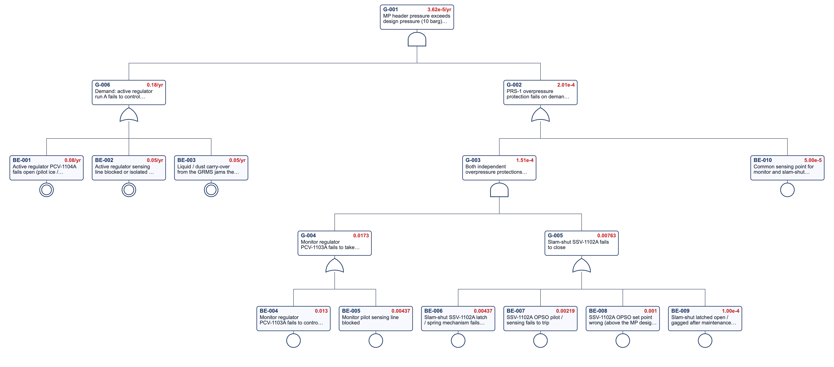
Figure 2 – FT-GN-01 – PRS-1 overpressure of the MP header (steel works gas network example) (rendered by the app)
Gate | Description | Result
G-001 | MP header pressure exceeds design pressure (10 barg) – PRS-1 overpressure | 3.62E-5 /yr
G-006 | Demand: active regulator run A fails to control (drives open) | 1.80E-1 /yr
G-002 | PRS-1 overpressure protection fails on demand (monitor regulator and slam-shut) | 2.01E-4
G-003 | Both independent overpressure protections fail | 1.51E-4
G-004 | Monitor regulator PCV-1103A fails to take over | 1.73E-2
G-005 | Slam-shut SSV-1102A fails to close | 7.63E-3

Main contributors | FV
Monitor regulator PCV-1103A fails to control (sticks / pilot fault) | 54.3 %
Active regulator PCV-1104A fails open (pilot ice / debris, diaphragm failure) | 44.4 %
Slam-shut SSV-1102A latch / spring mechanism fails to close | 41.4 %
Active regulator sensing line blocked or isolated – regulator drives open | 27.8 %
Liquid / dust carry-over from the GRMS jams the active regulator open | 27.8 %
Common sensing point for monitor and slam-shut blocked or isolated | 27.4 %

6.2 FT-GN-02 – HP / MP gas detection and ESD isolation fails on demand
Top event (G-001): a release is not isolated. PFDavg 2.6E-2 (RRF 38, SIL 1 band). Automatic initiation is limited by detector coverage (BE-005, 0.1) and is backed up by the manual ESD (G-004); the ESD valves tested annually dominate (G-005). Sensitivity: six-monthly partial-stroke testing of ESDV-1001 / ESDV-1107 (R-001) reduces the PFDavg to 2.0E-2.
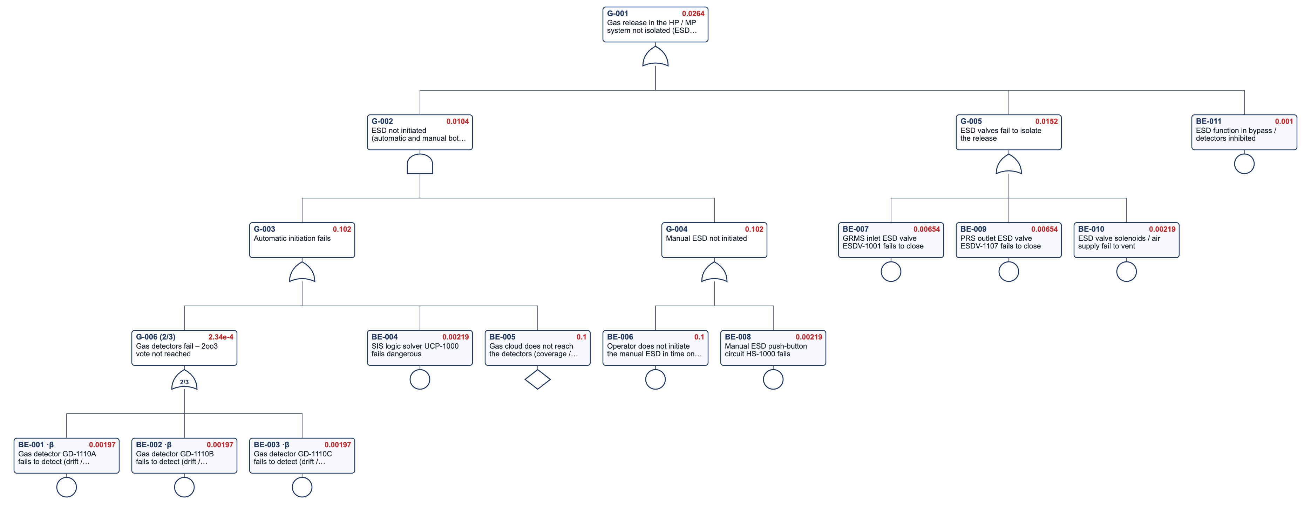
Figure 3 – FT-GN-02 – HP / MP gas detection and ESD isolation fails on demand (steel works gas network example) (rendered by the app)
Gate | Description | Result
G-001 | Gas release in the HP / MP system not isolated (ESD fails on demand) | 2.64E-2
G-002 | ESD not initiated (automatic and manual both fail) | 1.04E-2
G-003 | Automatic initiation fails | 1.02E-1
G-006 | Gas detectors fail – 2oo3 vote not reached | 2.34E-4
G-004 | Manual ESD not initiated | 1.02E-1
G-005 | ESD valves fail to isolate the release | 1.52E-2

Main contributors | FV
Operator does not initiate the manual ESD in time on gas alarm / field report | 37.9 %
Gas cloud does not reach the detectors (coverage / wind direction) | 37.9 %
GRMS inlet ESD valve ESDV-1001 fails to close | 24.3 %
PRS outlet ESD valve ESDV-1107 fails to close | 24.3 %
ESD valve solenoids / air supply fail to vent | 8.1 %
ESD function in bypass / detectors inhibited | 3.7 %

6.3 FT-GN-03 – Reheat furnace explosive mixture after flame failure
Top event: explosive mixture in the reheat furnace after a flame failure while the zone is below auto-ignition temperature. The BMS shut-off (G-002) has PFDavg 1.1E-2 – SIL 1 band, whereas a fired-equipment flame-failure function of this severity normally needs SIL 2. Top-event frequency 9.2E-3 /yr. The single flame scanner per burner, the logic solver and the trip bypass dominate.
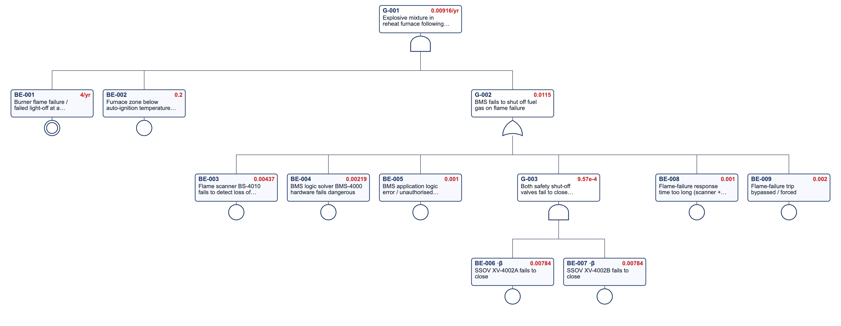
Figure 4 – FT-GN-03 – Reheat furnace explosive mixture after flame failure (steel works gas network example) (rendered by the app)
Gate | Description | Result
G-001 | Explosive mixture in reheat furnace following flame failure | 9.16E-3 /yr
G-002 | BMS fails to shut off fuel gas on flame failure | 1.15E-2
G-003 | Both safety shut-off valves fail to close (1oo2) | 9.57E-4

Main contributors | FV
Burner flame failure / failed light-off at a reheat furnace burner | 100.0 %
Furnace zone below auto-ignition temperature (start-up / low fire) | 100.0 %
Flame scanner BS-4010 fails to detect loss of flame | 37.9 %
BMS logic solver BMS-4000 hardware fails dangerous | 18.9 %
Flame-failure trip bypassed / forced | 17.3 %
BMS application logic error / unauthorised change | 8.6 %

7 Event tree analysis

7.1 ETA-GN-01 – Major natural gas release from the HP / MP system
Initiating event: a significant natural gas release from the HP / MP system at 5.8E-3 /yr – the top-event frequency of bow tie BT-GN-01. Heading H2 is the gas detection & ESD fault tree. All end states meet their targets; the VCE end state (4.3E-6 /yr) is 23 times below the catastrophic target, mainly because ESD isolation removes the large cloud. R-021 confirms the control-room siting against the VCE overpressure.
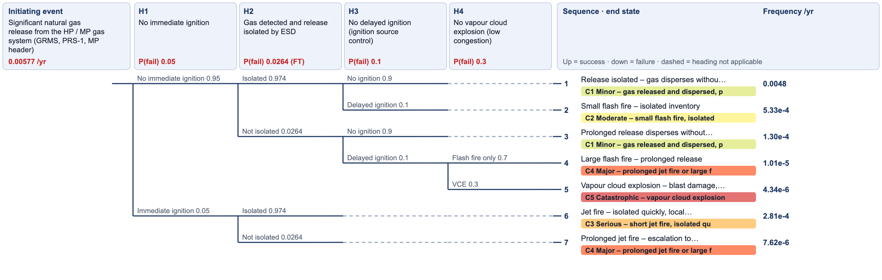
Figure 5 – ETA-GN-01 – Major natural gas release from the HP / MP system (steel works gas network example) (rendered by the app)
Heading | Description | P(failure) | Source
H1 | No immediate ignition | 5.00E-2 | High-pressure release, ignition at the source – illustrative; BT-GN-01
H2 | Gas detected and release isolated by ESD | 2.64E-2 | Fault tree FT-GN-02 G-001
H3 | No delayed ignition (ignition source control) | 1.00E-1 | = BT-GN-01 barrier 'Ignition source control'
H4 | No vapour cloud explosion (low congestion) | 3.00E-1 | Fraction of delayed ignitions in congested / confined areas (PRS shelt

# | End state | Category | Frequency /yr
1 | Release isolated – gas disperses without ignition | C1 | 4.8E-3
2 | Small flash fire – isolated inventory | C2 | 5.3E-4
3 | Prolonged release disperses without ignition – plant gas-out | C1 | 1.3E-4
4 | Large flash fire – prolonged release | C4 | 1.0E-5
5 | Vapour cloud explosion – blast damage, multiple fatalities | C5 | 4.3E-6
6 | Jet fire – isolated quickly, local damage | C3 | 2.8E-4
7 | Prolonged jet fire – escalation to heaters / filter-separators | C4 | 7.6E-6

Category | Description | Frequency /yr | Target /yr | Status
C1 | Minor – gas released and dispersed, plant gas-out | 4.9E-3 | – | –
C2 | Moderate – small flash fire, isolated inventory | 5.3E-4 | 1.0E0 | OK
C3 | Serious – short jet fire, isolated quickly | 2.8E-4 | 1.0E-1 | OK
C4 | Major – prolonged jet fire or large flash fire, escalation | 1.8E-5 | 1.0E-2 | OK
C5 | Catastrophic – vapour cloud explosion, multiple fatalities | 4.3E-6 | 1.0E-4 | OK

7.2 ETA-GN-02 – Reheat furnace flame failure
Initiating event: burner flame failure or failed light-off, 4 /yr. The furnace explosion end state is 9.2E-4 /yr against a target of 1E-4 /yr – the main risk gap of the study (HAZOP N06-01, R-010). Sensitivity (app engine): with self-checking 1oo2 flame scanners, a SIL-certified logic solver, six-monthly SSOV tests and bypass / MOC control the BMS PFDavg falls from 1.1E-2 to 2.1E-3 (SIL 2 band) and the explosion frequency to 1.7E-4 /yr – still 1.7 times the target, so further risk reduction is needed (see section 12).
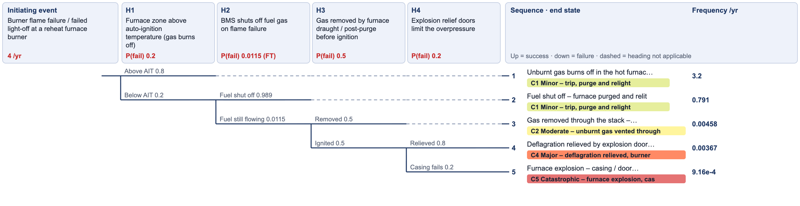
Figure 6 – ETA-GN-02 – Reheat furnace flame failure (steel works gas network example) (rendered by the app)
Heading | Description | P(failure) | Source
H1 | Furnace zone above auto-ignition temperature (gas burns off) | 2.00E-1 | = fault tree FT-GN-03 BE-002 and bow tie BT-GN-02 threat T1 condition
H2 | BMS shuts off fuel gas on flame failure | 1.15E-2 | Fault tree FT-GN-03 G-002
H3 | Gas removed by furnace draught / post-purge before ignition | 5.00E-1 | = bow tie BT-GN-02 barrier 'furnace draught / post-purge'
H4 | Explosion relief doors limit the overpressure | 2.00E-1 | = bow tie BT-GN-02 barrier 'explosion relief doors'

# | End state | Category | Frequency /yr
1 | Unburnt gas burns off in the hot furnace – trip and relight | C1 | 3.2E0
2 | Fuel shut off – furnace purged and relit | C1 | 7.9E-1
3 | Gas removed through the stack – post-purge, investigate | C2 | 4.6E-3
4 | Deflagration relieved by explosion doors – burner / refractory damage | C4 | 3.7E-3
5 | Furnace explosion – casing / door failure, potential fatalities | C5 | 9.2E-4

Category | Description | Frequency /yr | Target /yr | Status
C1 | Minor – trip, purge and relight | 4.0E0 | – | –
C2 | Moderate – unburnt gas vented through the stack, investigation | 4.6E-3 | 1.0E0 | OK
C4 | Major – deflagration relieved, burner / refractory damage, outage | 3.7E-3 | 1.0E-2 | OK
C5 | Catastrophic – furnace explosion, casing / door failure, potential fatalities | 9.2E-4 | 1.0E-4 | × 9.2 above target

8 Bow tie analysis

8.1 BT-GN-01 – Loss of containment of the HP / MP natural gas system
Six threats lead to loss of containment of the HP / MP system. Threat T1 uses the FT-GN-01 demand frequency and the FT-GN-01 protection PFDavg; the ESD barrier is FT-GN-02. The jet-fire, flash-fire and VCE residual frequencies are identical to the ETA-GN-01 end states. Flange / fitting failures (T4) dominate the top-event frequency – mechanical integrity, not the PRS, drives the release frequency.
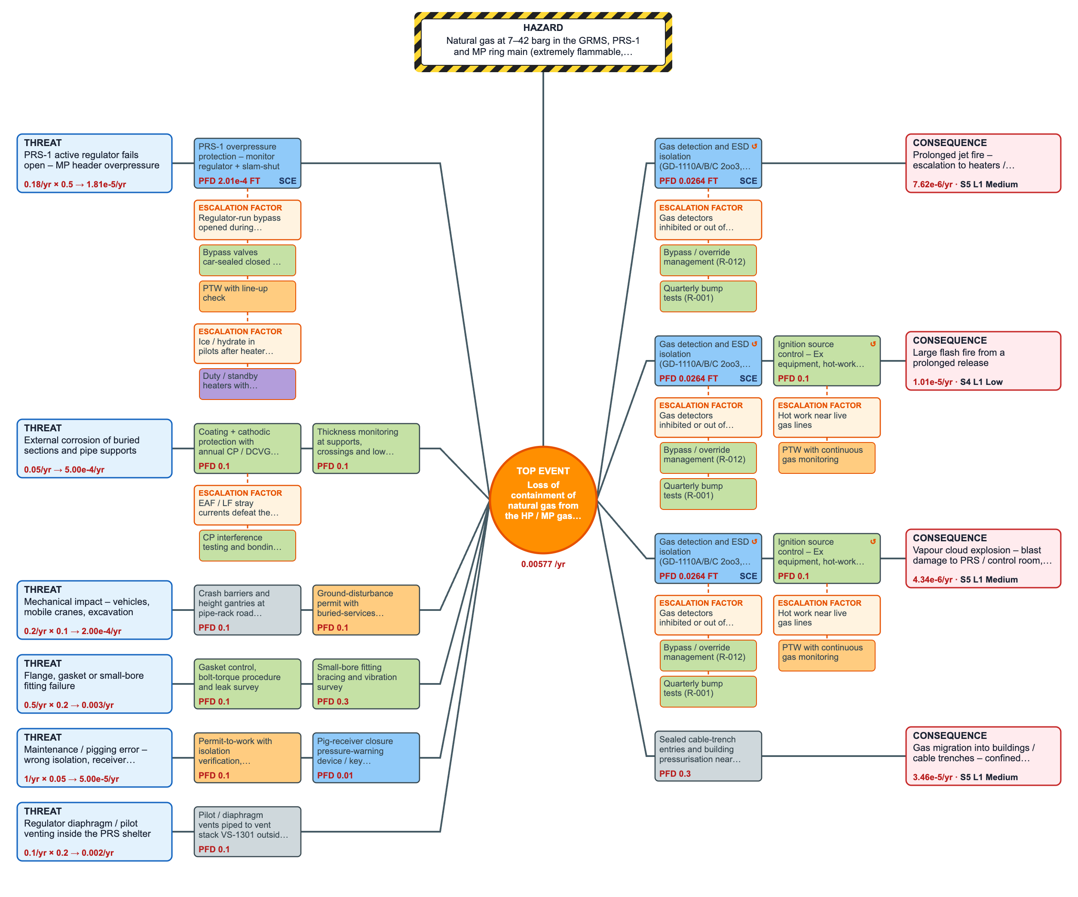
Figure 7 – BT-GN-01 – Loss of containment of the HP / MP natural gas system (steel works gas network example) (rendered by the app)
Threat | f /yr | Cond. | Preventive barriers (PFD) | Contribution /yr
PRS-1 active regulator fails open – MP header overpressure | 1.8E-1 | 0.5 | PRS-1 overpressure protection – monitor regulator + slam-shut (2.0E-4) | 1.8E-5
External corrosion of buried sections and pipe supports | 5.0E-2 | 1 | Coating + cathodic protection with annual CP / DCVG survey (1.0E-1)  Thickness monitoring at supports, crossings and low points (1.0E-1) | 5.0E-4
Mechanical impact – vehicles, mobile cranes, excavation | 2.0E-1 | 0.1 | Crash barriers and height gantries at pipe-rack road crossings (1.0E-1)  Ground-disturbance permit with buried-services drawing (1.0E-1) | 2.0E-4
Flange, gasket or small-bore fitting failure | 5.0E-1 | 0.2 | Gasket control, bolt-torque procedure and leak survey (1.0E-1)  Small-bore fitting bracing and vibration survey (3.0E-1) | 3.0E-3
Maintenance / pigging error – wrong isolation, receiver opened under pressure, hot work | 1.0E0 | 0.05 | Permit-to-work with isolation verification, gas-free test and fire watch (1.0E-1)  Pig-receiver closure pressure-warning device / key interlock (PR-1001) (1.0E-2) | 5.0E-5
Regulator diaphragm / pilot venting inside the PRS shelter | 1.0E-1 | 0.2 | Pilot / diaphragm vents piped to vent stack VS-1301 outside the shelter (1.0E-1) | 2.0E-3

Top-event frequency: 5.8E-3 /yr.
Consequence | Cond. | Mitigative barriers (PFD) | Residual /yr | S | Risk | Tolerable /yr
Prolonged jet fire – escalation to heaters / filter-separators | 0.05 | Gas detection and ESD isolation (GD-1110A/B/C 2oo3, UCP-1000, ESDV-1001 / ESDV-1107) (2.6E-2) | 7.6E-6 | 5 | Medium | 1e-4
Large flash fire from a prolonged release | 0.665 | Gas detection and ESD isolation (GD-1110A/B/C 2oo3, UCP-1000, ESDV-1001 / ESDV-1107) (2.6E-2)  Ignition source control – Ex equipment, hot-work permit, vehicle control (1.0E-1) | 1.0E-5 | 4 | Low | 0.01
Vapour cloud explosion – blast damage to PRS / control room, multiple fatalities | 0.285 | Gas detection and ESD isolation (GD-1110A/B/C 2oo3, UCP-1000, ESDV-1001 / ESDV-1107) (2.6E-2)  Ignition source control – Ex equipment, hot-work permit, vehicle control (1.0E-1) | 4.3E-6 | 5 | Medium | 1e-4
Gas migration into buildings / cable trenches – confined explosion | 0.02 | Sealed cable-trench entries and building pressurisation near the MP header (3.0E-1) | 3.5E-5 | 5 | Medium | 1e-4

Safety-critical barriers (SCE): PRS-1 overpressure protection – monitor regulator + slam-shut; Gas detection and ESD isolation (GD-1110A/B/C 2oo3, UCP-1000, ESDV-1001 / ESDV-1107).

8.2 BT-GN-02 – Explosive mixture in the reheat furnace
Threat T1 (flame failure below auto-ignition temperature, BMS barrier = FT-GN-03 G-002) contributes 9.2E-3 /yr – equal to the FT-GN-03 top event and to the ETA-GN-02 'fuel still flowing' branch. The furnace explosion consequence is above the tolerable frequency, confirming R-010 and R-011.
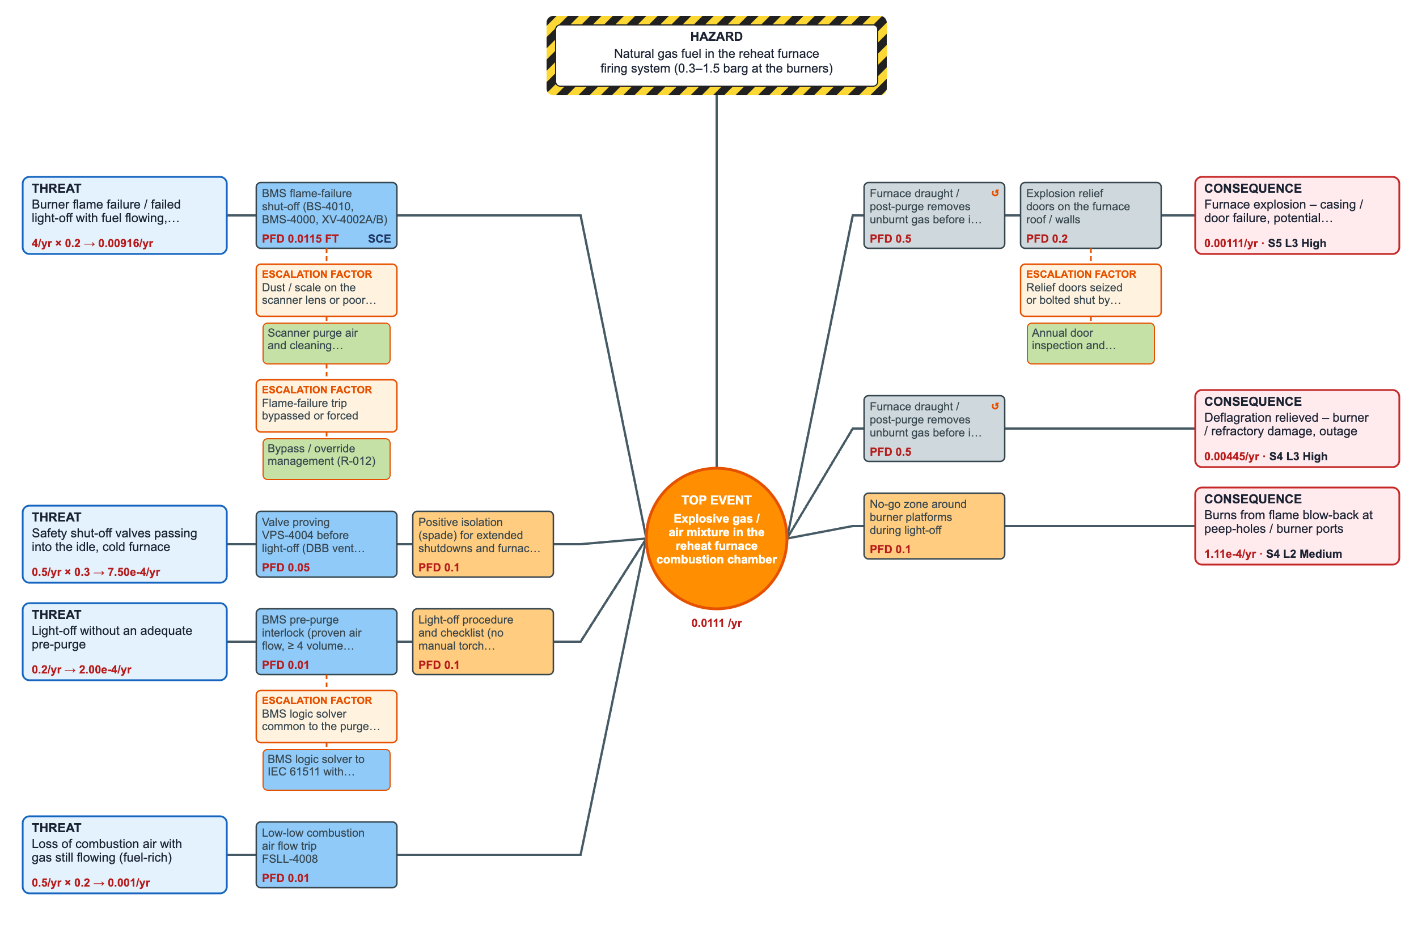
Figure 8 – BT-GN-02 – Explosive mixture in the reheat furnace (steel works gas network example) (rendered by the app)
Threat | f /yr | Cond. | Preventive barriers (PFD) | Contribution /yr
Burner flame failure / failed light-off with fuel flowing, furnace below auto-ignition temperature | 4.0E0 | 0.2 | BMS flame-failure shut-off (BS-4010, BMS-4000, XV-4002A/B) (1.1E-2) | 9.2E-3
Safety shut-off valves passing into the idle, cold furnace | 5.0E-1 | 0.3 | Valve proving VPS-4004 before light-off (DBB vent XV-4003) (5.0E-2)  Positive isolation (spade) for extended shutdowns and furnace entry (1.0E-1) | 7.5E-4
Light-off without an adequate pre-purge | 2.0E-1 | 1 | BMS pre-purge interlock (proven air flow, ≥ 4 volume changes) (1.0E-2)  Light-off procedure and checklist (no manual torch lighting) (1.0E-1) | 2.0E-4
Loss of combustion air with gas still flowing (fuel-rich) | 5.0E-1 | 0.2 | Low-low combustion air flow trip FSLL-4008 (1.0E-2) | 1.0E-3

Top-event frequency: 1.1E-2 /yr.
Consequence | Cond. | Mitigative barriers (PFD) | Residual /yr | S | Risk | Tolerable /yr
Furnace explosion – casing / door failure, potential fatalities | 1 | Furnace draught / post-purge removes unburnt gas before it ignites (5.0E-1)  Explosion relief doors on the furnace roof / walls (2.0E-1) | 1.1E-3 | 5 | High | 1e-4
Deflagration relieved – burner / refractory damage, outage | 0.8 | Furnace draught / post-purge removes unburnt gas before it ignites (5.0E-1) | 4.4E-3 | 4 | High | 0.01
Burns from flame blow-back at peep-holes / burner ports | 0.1 | No-go zone around burner platforms during light-off (1.0E-1) | 1.1E-4 | 4 | Medium | 0.01

Safety-critical barriers (SCE): BMS flame-failure shut-off (BS-4010, BMS-4000, XV-4002A/B).

9 How the tools link – cross-reference matrix
Item | HAZOP | FMECA | Fault tree | Event tree | Bow tie | Value
PRS overpressure protection (monitor + slam-shut) | N02-02 [IPL] MON, SSV | S02 PCV-1103A, SSV-1102A | FT-GN-01 G-002 | – | BT-GN-01 barrier (T1) | 2.0E-4
MP header overpressure frequency | N02-02, N03-02 L-after | S02 PCV-1104A (demand) | FT-GN-01 top | – | BT-GN-01 T1 ÷ cond 0.5 | 3.6E-5 /yr
Gas detection & ESD isolation | N01-05, N02-05, N08-01 [IPL] | S01 ESDV-1001, S08 GD-1110A, UCP-1000, HS-1000 | FT-GN-02 G-001 | ETA-GN-01 H2 | BT-GN-01 ESD barrier | 2.6E-2
HP / MP loss of containment | N01-05, N02-05, N03-01 | S01, S03 | – | ETA-GN-01 IE | BT-GN-01 top | 5.8E-3 /yr
Vapour cloud explosion | N01-05 L-after | – | – | ETA-GN-01 C5 | BT-GN-01 'VCE' residual | 4.3E-6 /yr
Furnace BMS flame-failure shut-off | N06-01 [IPL] BMS | S06 BS-4010, XV-4002A, BMS-4000 | FT-GN-03 G-002 | ETA-GN-02 H2 | BT-GN-02 BMS barrier (T1) | 1.1E-2
Explosive mixture after flame failure | N06-01 | – | FT-GN-03 top | ETA-GN-02 H1-fail × H2-fail | BT-GN-02 T1 contribution | 9.2E-3 /yr
Furnace explosion | N06-01 L-after | – | – | ETA-GN-02 C5 | BT-GN-02 consequence | 9.2E-4 /yr
P(below auto-ignition temperature) | N06-01 | – | FT-GN-03 BE-002 | ETA-GN-02 H1 | BT-GN-02 T1 cond. | 0.2
Draught / relief doors | N06-01 DRAUGHT, EXPDOORS | – | – | ETA-GN-02 H3, H4 | BT-GN-02 barriers | 0.5 / 0.2
Ignition source control | N01-05, N02-05 IGN | – | – | ETA-GN-01 H3 | BT-GN-01 barrier | 0.1

The same tags, node numbers (N01–N08 = S01–S08), document codes and recommendation numbers are used in every file. Fault trees are embedded in the event-tree and bow-tie files as live links, so changing a failure rate in the fault tree changes the ETA heading and the bow-tie barrier when the file is re-imported.

10 Verification of the example (cross-link tests)
Every file was re-opened in its toolkit app and recalculated by the app's own engine; the workbooks were recalculated in LibreOffice. The automated test script (test_gn_example.py) then checked that the numbers, references and tags agree across all tools. Results of the last run before this report was issued:
Check group | Passed | Failed
A. Apps | 34 | 0
B. Numbers | 49 | 0
C. References | 155 | 0
D. Tags | 56 | 0
E. Workbooks | 113 | 0
W. What-If | 32 | 0
F. Report | 31 | 0
Total | 470 | 0

Examples of what is checked: ETA headings and bow-tie barriers equal the linked fault-tree gates; the event-tree initiating frequency equals the bow-tie top event; bow-tie residual frequencies equal the event-tree end states; HAZOP likelihoods equal the calculated frequency bands; every Nxx-yy, R-0xx, FT / ETA / BT code and equipment tag resolves; the workbooks match the app study row by row with valid drop-down values and no formula errors; the macro workbooks keep their VBA.

11 Recommendations register
No. | Recommendation | Priority | Action by | HAZOP refs | Due
R-001 | Verify the HP / MP gas detection & ESD function against the required risk reduction. Fault tree FT-GN-02 gives PFDavg 2.6E-2 (RRF 38); test the effect of six-monthly partial-stroke testing of ESDV-1001 / ESDV-1107 and quarterly detector bump tests (FMECA S01 / S08). | High | Instrument engineer | N01-05, N02-05, N08-01, N08-04 | 2027-03-31
R-002 | Confirm and record PRS-1 set-point staggering (active 7.0 / monitor 7.5 / SSV OPSO 8.5 / PSV-1105 9.0 barg; MP design 10 barg) in the PRS data sheet; add the regulator-run bypass valves to the car-seal (CSC) register. | High | Process engineer | N02-02, N02-07 | 2027-03-31
R-003 | Introduce an annual lock-up / take-over test of monitor regulators PCV-1103A/B and a six-monthly trip test of slam-shut valves SSV-1102A/B – these intervals are the basis of fault tree FT-GN-01 (protection PFDavg 2.0E-4). | High | Instrument engineer | N02-02, N03-02 | 2027-03-31
R-004 | Confirm the minimum PRS outlet gas temperature against the MDMT of the downstream piping; add automatic change-over to the standby heater on TSL-1101 and an alarm on heater trip. | Medium | Process engineer | N02-01, N02-06 | 2027-06-30
R-005 | Route all regulator pilot / diaphragm vents and the PSV-1105 discharge to vent stack VS-1301 outside the PRS shelter; confirm by dispersion check that the vent is clear of heater flues and platforms. | High | Process engineer | N02-05, N02-07, N07-04 | 2027-03-31
R-006 | Agree a supply-interruption and restoration protocol with the gas supplier: users isolated before re-pressurisation, controlled restoration sequence, BMS re-start only after confirmed header pressure. | Medium | Utilities manager | N01-01, N02-03 | 2027-06-30
R-007 | Install gas detection at the HVAC intakes and cable-trench entries of buildings near the MP header (substations, control rooms) with HVAC trip. | High | HSE / process safety | N03-01, N05-02 | 2027-03-31
R-008 | Survey stray currents and induced voltages on gas pipework near the EAF / LF high-current systems; verify insulating joints and bonding; include in CP interference testing. | Medium | Electrical engineer | N01-06, N03-05 | 2027-06-30
R-009 | Include buried gas-line routes in the ground-disturbance permit; mark crossings on site; review crash protection and height gantries at pipe-rack road crossings. | Medium | Civil engineer | N03-01, N03-04 | 2027-06-30
R-010 | Upgrade the reheat furnace flame-failure shut-off to meet SIL 2 (fault tree FT-GN-03 PFDavg 1.1E-2 = SIL 1 band; event tree ETA-GN-02 explosion frequency 9.2E-4 /yr vs target 1E-4): self-checking UV scanners 1oo2 per burner, proof-tested SSOVs, BMS logic solver to IEC 61511 / EN 746-2. | High | Instrument engineer | N06-01 | 2027-03-31
R-011 | Valve proving (VPS-4004) of XV-4002A/B before every light-off; positive isolation (spade) for furnace entry and extended shutdowns (bow tie BT-GN-02 threat 2). | High | Rolling-mill superintendent | N06-05, N06-07 | 2027-03-31
R-012 | Bypass / override management for BMS, SIS and gas detectors: authorisation, time limit, logging and monthly audit; BMS logic changes only under MOC. | High | HSE / process safety | N05-03, N05-04, N06-01, N06-04, N06-06, N08-04 | 2027-03-31
R-013 | Fit / verify non-return valves and flashback arrestors on the NG and O2 lines at every EAF oxy-fuel burner and ladle preheater; prove the 'low NG pressure closes O2' interlock annually. | High | Melt shop maintenance | N05-01 | 2027-03-31
R-014 | N2 purge connections to the gas system by removable spool / hose only, with check valve and double block & bleed; disconnect after use (prevents NG back-flow into the plant N2 header that also feeds the hot DRI conveyor N2 system XS-210). | High | Utilities manager | N07-03 | 2027-03-31
R-015 | Purge plan for every gas-in / gas-out: N2 purge with O2 < 2 % confirmed before gas-in and gas > 90 % confirmed at the vent before relight; calibrated portable analysers. | Medium | Operations superintendent | N03-03, N07-01, N07-06 | 2027-06-30
R-016 | Route the filter-separator drains to a closed drain vessel instead of an open drain; review the LSH-1002 alarm response. | Medium | Process engineer | N01-03 | 2027-06-30
R-017 | Verify the pig-receiver quick-opening closure safety device (pressure-warning / key interlock with the vent valve) and include it in the pigging procedure and its training. | High | Mechanical engineer | N01-05, N01-07 | 2027-03-31
R-018 | Provide reverse-flow protection at the DRI process-gas NG make-up point: double check valves plus a PDALL-2009 trip closing XV-2008; annual reverse-flow leak test. | High | DRI process engineer | N04-03 | 2027-03-31
R-019 | Heat-shield and re-route NG lines and hoses near the EAF and ladle area; six-monthly hose inspection and replacement on condition. | Medium | Melt shop maintenance | N05-02 | 2027-06-30
R-020 | Gas alarm response procedure and drills – the manual ESD is credited in fault tree FT-GN-02 (gate G-004) with an operator failure probability of 0.1. | Medium | Operations superintendent | N08-01, N08-03 | 2027-06-30
R-021 | Assess the vapour cloud explosion overpressure at the PRS / GRMS and verify the siting of the utilities control room (bow tie BT-GN-01 / event tree ETA-GN-01 VCE end state). | Medium | HSE / process safety | N01-05 | 2027-06-30

12 Conclusions
- Reheat furnace (N06): the BMS flame-failure shut-off achieves only PFDavg 1.1E-2 (SIL 1 band); the furnace explosion frequency 9.2E-4 /yr is about 9 times the 1E-4 /yr target. R-010 (SIL 2 upgrade, PFDavg 2.1E-3) reduces it to 1.7E-4 /yr in the sensitivity case – still 1.7 times the target, so the SIL 2 BMS alone is not enough: the team should also reduce the demand (fewer cold light-offs / flame failures, burner maintenance) or credit an additional layer such as a furnace-atmosphere combustibles analyser trip, and reassess with the event tree; R-011 / R-012 address passing valves and bypasses.
- PRS-1 (N02): two independent self-acting protections give PFDavg 2.0E-4 and an MP overpressure frequency of 3.6E-5 /yr – acceptable provided the proof tests on which the fault tree is based are actually done (R-003) and the bypasses are car-sealed (R-002).
- Major releases (N01–N03): the loss-of-containment frequency 5.8E-3 /yr is dominated by flange / fitting failures, not by the PRS; all event-tree outcomes are within target. The ESD function (PFDavg 2.6E-2, RRF 38) is limited by detector coverage and annual ESD valve testing (R-001).
- Interfaces specific to a steel works were identified: O2 back-flow at oxy-fuel burners (R-013), process-gas back-flow at the DRI make-up point (R-018), EAF stray currents (R-008) and NG back-flow into the plant N2 header that also feeds the hot DRI conveyor fire-protection system (R-014).
- FMECA and HAZOP agree on where the risk lies: hidden failures of protective equipment carry the highest RPNs, and their proof-test intervals are the inputs of the fault trees.

13 Limitations
Illustrative data throughout (failure rates, frequencies, conditional probabilities, consequence severities). Consequence modelling (dispersion, radiation, overpressure) was not performed – end-state severities are judgement. Human error probabilities are generic screening values. The example is for training in the method and in the toolkit, not a study of any real plant.

